

**KENDRIYA VIDYALAYA**

**NO-2 ARMY BHUJ**

**(2020-21)**

**C.S INVESTIGATORY PROJECT**

**TOPIC:**

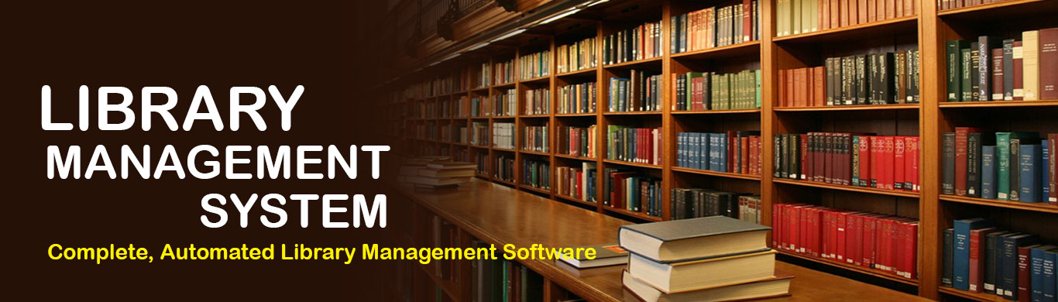

**SUMITTED BY- Tushar Patel**

**Dhruv Gautam**

**CERTIFICATE**

*This is to certify that* ***Tushar Patel, Dhruv Gautam*** *student of Class* ***XII-Science******KENDRIYA VIDALAYA NO-2 ARMY BHUJ*** *has completed the project titled* ***“School and Fee management”****during the academic year 2020-2021 towards partial fulfillment of credit for the CS practical evaluation of CBSE 2021, and submitted satisfactory report, as compiled in the following pages, under my supervision.*

**Sh. B.L Kashyap External**

**(PGT C.S) Examiner**

**Sh. Rajesh.Trivadi**

**(Principal)**

**Acknowledgement**

***I am highly grateful to Mr. B.L Kashyap, our CS teacher, for his kind guidance and encouragement. Without his untiring help, it would not have been possible for me to perform this project. My special thanks to our respected principal Sh. Rajesh.Trivadi for his inspiration and motivation. Too many thanks to our willingly or unwilling contribution to this project and whose name do not appear here, I expected big thanks.***

***I wish to thanks MY PARENTS for their undivided support & interest who inspired me &encouraged me to go my own way, without which I would be unable to complete my project. And at last by no means the least I would thanks to God who made the entire thing possible.***

**INDEX**

* **Overview of Python**
* **Introduction**
* **Requirements**

1. **Software Specifications**

* **Python Coding**
* **Outputs**
* **Bibliography**



Python is a high-level, interpreted, interactive and object-oriented scripting language. Python is designed to be highly readable. It uses English keywords frequently where as other languages use punctuation, and it has fewer syntactical constructions than other languages.

* **Python is Interpreted** − Python is processed at runtime by the interpreter. You do not need to compile your program before executing it. This is similar to PERL and PHP.
* **Python is Interactive** − You can actually sit at a Python prompt and interact with the interpreter directly to write your programs.
* **Python is Object-Oriented** − Python supports Object-Oriented style or technique of programming that encapsulates code within objects.
* **Python is a Beginner's Language** − Python is a great language for the beginner-level programmers and supports the development of a wide range of applications from simple text processing to WWW browsers to games

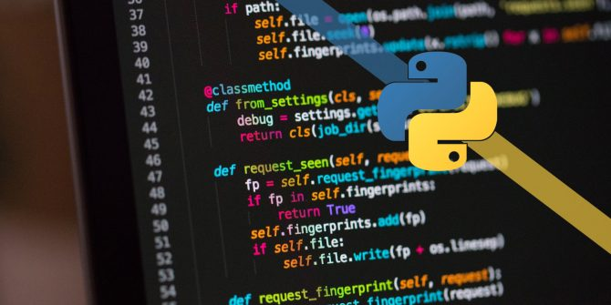

**INTRODUCTION**

This project is Library management system for monitoring and controlling the transactions of Books in a library. “Library Management System” is a Python(Tkinter) application, designed to help users maintain and organize library Books. A library is a collection of sources of information and similar resources, made accessible to a defined community for reference or borrowing. This System keeps track of all the information about the Transaction of books in the library. The user will find it easy in this automated system rather than using the manual writing system. The system contains a database where all the information about the user will be saved safely. This project is designed And coded in Python(Tkinter) and Database management is handled by MySQL.

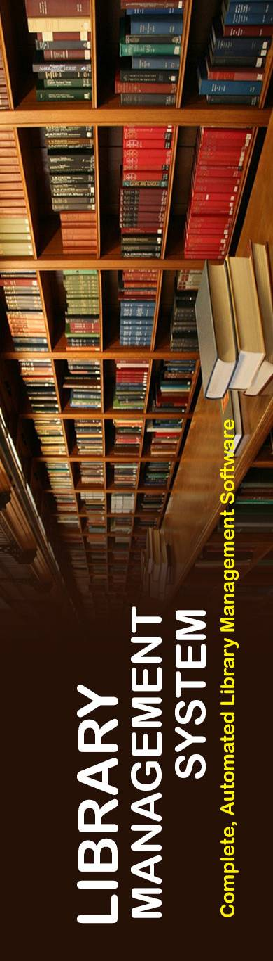

**Requirements**

**Software Specifications**

**1. Python (3.7.4)**

* **Os**
* **Mysql.connector**
* **Tkinter**

**2. Microsoft Word 10**

**CODING**



**from tkinter import \***

**from tkinter import messagebox**

**import os**

**import mysql.connector as db**

**from tkinter import ttk**

**def One_submit_button_stu():**

**try:**

**global d_name**

**global tv**

**global One_entry**

**global adminno_entry**

**global adminno**

**global stu_tv**

**global ref_entry**

**ID = One_entry.get()**

**d_name = database_name.get()**

**mydb = db.connect(host="localhost", user="root", password="root", database=d_name)**

**cursor = mydb.cursor()**

**cursor.execute("select * from student_data where Reference_no=%s" %ID)**

**one = cursor.fetchall()**

**if one== []:**

**messagebox.showerror("Error", "No row with entered reference no. exist..")**

**for i in one:**

**stu_tv.insert("", 'end', values=i)**

**except:**

**messagebox.showerror("ERROR","""1. Please make sure you have entered and integer value.**

**2. student_Library table exist in your database """)**

**def show_stu_one():**

**global stu**

**global stu_tv**

**global One_entry**

**showone_win = Toplevel(stu)**

**showone_win.title("ONE RECORD")**

**showone_win.geometry("1300x250")**

**showone_win.config(bg="#525252")**

**# frame_one= LabelFrame(showone_win)**

**# frame_one.grid()**

**Label(showone_win,text="Enter exact Reference No. below to display the Particular record:-",font=("Chiller","20"),bg="#525252", fg="#f6f6e9").grid(row=0,column=0,padx=50)**

**One_entry = Entry(showone_win, width=20, borderwidth=3, bg="#212121", fg="#8ef6e4")**

**One_entry.grid(row=1, column=0,pady=10)**

**One_submit_btn = Button(showone_win, text="Submit", command=One_submit_button_stu, bg="#525252", fg="#8ef6e4")**

**One_submit_btn.grid(row=2, column=0,pady=10)**

**stu_tv = ttk.Treeview(showone_win, columns=(1, 2, 3, 4, 5, 6, 7, 8, 9, 10, 11,12,13), show="headings",height="5")**

**stu_tv.grid(row=3,pady=30)**

**stu_tv.heading(1, text='Reference_No')**

**stu_tv.column(1, width=100)**

**stu_tv.heading(2, text='Admission_No')**

**stu_tv.column(2, width=100)**

**stu_tv.heading(3, text='student_name')**

**stu_tv.column(3, width=130)**

**stu_tv.heading(4, text='class_sec')**

**stu_tv.column(4, width=70)**

**stu_tv.heading(5, text='stream')**

**stu_tv.column(5, width=70)**

**stu_tv.heading(6, text='Book_borrowed')**

**stu_tv.column(6, width=140)**

**stu_tv.heading(7, text='bookID')**

**stu_tv.column(7, width=70)**

**stu_tv.heading(8, text='Author_name')**

**stu_tv.column(8, width=140)**

**stu_tv.heading(9, text='bookMRP')**

**stu_tv.column(9, width=70)**

**stu_tv.heading(10, text='Date_borrowed')**

**stu_tv.column(10, width=100)**

**stu_tv.heading(11, text='Due_Date')**

**stu_tv.column(11, width=80)**

**stu_tv.heading(12, text='State')**

**stu_tv.column(12, width=100)**

**stu_tv.heading(13, text='Phone_No')**

**stu_tv.column(13, width=110)**

**# scrollbar vertical**

**scroll_v = ttk.Scrollbar(showone_win, orient="vertical", command=stu_tv.yview)**

**stu_tv.configure(yscroll=scroll_v.set)**

**scroll_v.grid(row=3, column=12, sticky="ns")**

**def show_one_connect():**

**try:**

**global stu**

**global stu_add**

**global d_name**

**global database_name_entry**

**global database_name**

**global adminno_entry**

**global adminno**

**d_name = database_name.get()**

**mydb = db.connect(host="localhost", user="root", password="root")**

**cursor = mydb.cursor()**

**cursor.execute("use %s" % d_name)**

**messagebox.showinfo("", "Database connected succesfully")**

**next_add_button = Button(stu_add, text="Next", bg="#525252", fg="#f8fcfb", state=ACTIVE, command=show_stu_one)**

**next_add_button.grid(row=2, column=1)**

**except:**

**messagebox.showerror("Database ERROR 1049 ","No such database found.please check spelling or make one from 'create student Table'")**

**def showone_win():**

**global stu**

**global stu_add**

**global database_name**

**global adminno_entry**

**stu_add = Toplevel(stu)**

**stu_add.title("STUDENT WINDOW-UPDATE")**

**stu_add.geometry("250x400")**

**stu_add.config(bg="#525252")**

**database_label = Label(stu_add, text="Enter Database name :-", bg="#525252", fg="#c9fdd7")**

**database_label.grid()**

**database_name = Entry(stu_add, width=20, borderwidth=2, bg="#525252", fg="#f8fcfb")**

**database_name.grid()**

**submit_button = Button(stu_add, text="Submit", command=show_one_connect, bg="#525252", fg="#f8fcfb")**

**submit_button.grid(pady=5)**

**next_add_button = Button(stu_add, text="Next", bg="#525252", fg="#f8fcfb", state=DISABLED)**

**next_add_button.grid(row=2, column=1)**

**def show_stu_all():**

**global stu**

**global d_name**

**global stu_tv**

**showall_win = Toplevel(stu)**

**showall_win.title("ALL RECORDS")**

**showall_win.geometry("1300x550")**

**showall_win.config(bg="#525252")**

**show_frame= LabelFrame(showall_win)**

**show_frame.grid()**

**Label(show_frame,text="ALL RECORDS",font=("lucida grande","20"),bg="#525252", fg="#f6f6e9").grid()**

**stu_tv = ttk.Treeview(showall_win,columns=(1,2,3,4,5,6,7,8,9,10,11,12,13),show="headings",height="15")**

**stu_tv.grid()**

**stu_tv.heading(1, text='Reference_No')**

**stu_tv.column(1, width=100)**

**stu_tv.heading(2,text='Admission_No')**

**stu_tv.column(2,width=100)**

**stu_tv.heading(3, text='student_name')**

**stu_tv.column(3,width=130)**

**stu_tv.heading(4, text='class_sec')**

**stu_tv.column(4,width=70)**

**stu_tv.heading(5, text='stream')**

**stu_tv.column(5,width=70)**

**stu_tv.heading(6, text='Book_borrowed')**

**stu_tv.column(6,width=140)**

**stu_tv.heading(7, text='bookID')**

**stu_tv.column(7,width=70)**

**stu_tv.heading(8, text='Author_name')**

**stu_tv.column(8,width=140)**

**stu_tv.heading(9, text='bookMRP')**

**stu_tv.column(9,width=70)**

**stu_tv.heading(10, text='Date_borrowed')**

**stu_tv.column(10,width=100)**

**stu_tv.heading(11, text='Due_Date')**

**stu_tv.column(11,width=80)**

**stu_tv.heading(12, text='State')**

**stu_tv.column(12, width=100)**

**stu_tv.heading(13, text='Phone_No')**

**stu_tv.column(13,width=110)**

**#scrollbar vertical**

**scroll_v = ttk.Scrollbar(showall_win,orient="vertical",command=stu_tv.yview)**

**stu_tv.configure(yscroll=scroll_v.set)**

**scroll_v.grid(row=0,column=13,sticky="ns")**

**d_name = database_name.get()**

**mydb = db.connect(host="localhost", user="root", password="root",database=d_name)**

**cursor = mydb.cursor()**

**cursor.execute("select * from student_data")**

**result = cursor.fetchall()**

**for i in result:**

**stu_tv.insert("", 'end', values=i)**

**def show_all_connect():**

**try:**

**global stu**

**global stu_add**

**global d_name**

**global database_name_entry**

**global database_name**

**global adminno_entry**

**global adminno**

**d_name = database_name.get()**

**mydb = db.connect(host="localhost", user="root", password="root")**

**cursor = mydb.cursor()**

**cursor.execute("use %s" % d_name)**

**messagebox.showinfo("", "Database connected succesfully")**

**next_add_button = Button(stu_add, text="Next", bg="#525252", fg="#f8fcfb", state=ACTIVE,command=show_stu_all)**

**next_add_button.grid(row=2, column=1)**

**except:**

**messagebox.showerror("Database ERROR 1049 ","No such database found.please check spelling or make one from 'create student Table'")**

**def show_allstu_submit():**

**global stu**

**global stu_add**

**global database_name**

**global adminno_entry**

**stu_add = Toplevel(stu)**

**stu_add.title("STUDENT WINDOW-UPDATE")**

**stu_add.geometry("250x400")**

**stu_add.config(bg="#525252")**

**database_label = Label(stu_add, text="Enter Database name :-", bg="#525252", fg="#c9fdd7")**

**database_label.grid()**

**database_name = Entry(stu_add, width=20, borderwidth=2, bg="#525252", fg="#f8fcfb")**

**database_name.grid()**

**submit_button = Button(stu_add, text="Submit", command=show_all_connect, bg="#525252", fg="#f8fcfb")**

**submit_button.grid(pady=5)**

**next_add_button = Button(stu_add, text="Next", bg="#525252", fg="#f8fcfb", state=DISABLED)**

**next_add_button.grid(row=2, column=1)**

**def save_updated_data():**

**global frame_Dbase**

**global stu**

**global stu_add**

**global d_name**

**global database_name_entry**

**global database_name**

**global adminno_entry**

**global stuname_entry**

**global classec_entry**

**global stream_entry**

**global Bookborrow_entry**

**global Author_entry**

**global bookid_entry**

**global Dateborrwed_entry**

**global Duedate_entry**

**global MRP_entry**

**global Phoneno_entry**

**global ref_entry**

**global state_entry**

**dname = database_name.get()**

**ref_no =ref_entry.get()**

**adminno = adminno_entry.get()**

**studentname = stuname_entry.get()**

**class_sec = classec_entry.get()**

**stu_stream = stream_entry.get()**

**borrowB = Bookborrow_entry.get()**

**B_ID = bookid_entry.get()**

**Author_name = Author_entry.get()**

**mrp = MRP_entry.get()**

**borrow_D = Dateborrwed_entry.get()**

**D_date = Duedate_entry.get()**

**state_stu = state_entry.get()**

**P_no = Phoneno_entry.get()**

**mydb = db.connect(host="localhost", user="root", password="root", database=str(d_name))**

**cursor = mydb.cursor()**

**add= "update student_data set admission_no=%s,student_name=%s,class_section=%s,stream=%s,book_borrowed=%s,bookID=%s,author_name=%s,bookMRP=%s,date_borrowed=%s,Due_date=%s,state=%s,phoneNo=%s where Reference_no =%s"**

**data= (adminno,studentname,class_sec,stu_stream,borrowB,B_ID,Author_name,mrp,borrow_D,D_date,state_stu,P_no,ref_no)**

**cursor.execute(add,data)**

**mydb.commit()**

**messagebox.showinfo("UPDATED","DATA UPDATED SUCCESSFULLY")**

**save = Button(frame_Dbase, text="SAVE RECORD", borderwidth=2, padx=14, bg="#525252", fg="#8ef6e4",state=DISABLED)**

**save.grid(pady=10, sticky=NSEW, row=13, column=1)**

**def Save_stu_Rec():**

**global adminno_entry**

**global stuname_entry**

**global classec_entry**

**global stream_entry**

**global Bookborrow_entry**

**global Author_entry**

**global bookid_entry**

**global Dateborrwed_entry**

**global Duedate_entry**

**global MRP_entry**

**global Phoneno_entry**

**global delete_stu_win**

**global stu**

**global dname**

**global frame_Dbase**

**global adminno**

**global ref_entry**

**global state_entry**

**dname = database_name.get()**

**ref_no = ref_entry.get()**

**adminno = adminno_entry.get()**

**studentname = stuname_entry.get()**

**class_sec = classec_entry.get()**

**stu_stream = stream_entry.get()**

**borrowB = Bookborrow_entry.get()**

**B_ID = bookid_entry.get()**

**Author_name = Author_entry.get()**

**mrp = MRP_entry.get()**

**borrow_D = Dateborrwed_entry.get()**

**D_date = Duedate_entry.get()**

**state_stu= state_entry.get**

**P_no = Phoneno_entry.get()**

**mydb = db.connect(host="localhost", password="root", user="root", database=dname)**

**cursor = mydb.cursor()**

**cursor.execute("select * from student_data where reference_no=%s" % ref_no)**

**all = cursor.fetchall()**

**for result in all:**

**adminno_entry.insert(0,result[1])**

**stuname_entry.insert(0,result[2])**

**classec_entry.insert(0,result[3])**

**stream_entry.insert(0,result[4])**

**Bookborrow_entry.insert(0,result[5])**

**bookid_entry.insert(0,result[6])**

**Author_entry.insert(0,result[7])**

**MRP_entry.insert(0,result[8])**

**Dateborrwed_entry.insert(0,result[9])**

**Duedate_entry.insert(0,result[10])**

**state_entry.insert(0,result[11])**

**Phoneno_entry.insert(0,result[12])**

**save = Button(frame_Dbase, text="SAVE RECORD", borderwidth=2, padx=14, bg="#525252", fg="#8ef6e4",command=save_updated_data,state=ACTIVE)**

**save.grid(pady=10, sticky=NSEW, row=13, column=1)**

**def update_win():**

**global frame_Dbase**

**global stu**

**global stu_add**

**global d_name**

**global stu_update**

**global database_name_entry**

**global database_name**

**global adminno_entry**

**global stuname_entry**

**global classec_entry**

**global stream_entry**

**global Bookborrow_entry**

**global Author_entry**

**global bookid_entry**

**global Dateborrwed_entry**

**global Duedate_entry**

**global MRP_entry**

**global Phoneno_entry**

**global ref_entry**

**global state_entry**

**stu_update = Toplevel(stu)**

**stu_update.geometry("600x700")**

**stu_update.title("UPDATE RECORD")**

**stu_update.config(bg="#525252")**

**frame_Dbase = LabelFrame(stu_update, borderwidth=5, height=5, bg="#525252")**

**frame_Dbase.grid(padx=80, pady=10)**

**Label(stu_update, text="Only enter Reference no. and rest fields program will fill on its own. ",font=("lucida grande", "10"),bg="#525252", fg="#f6f6e9").grid()**

**Label(stu_update, text="Note:- 1.only one record is going to update at once and you can not change the reference no. ",font=("lucida grande", "10"),bg="#525252", fg="#f6f6e9").grid()**

**Label(stu_update, text=" 2.You have to entered exact reference no. otherwise it will not fill the entry fields ", font=("lucida grande", "10"),bg="#525252", fg="#f6f6e9").grid()**

**ref_label = Label(frame_Dbase, text="Reference No :-", font=("lucida grande", "15"),bg="#525252", fg="#c7ffff")**

**adminno_label = Label(frame_Dbase, text="Admission No :-", font=("lucida grande", "15"),bg="#525252", fg="#c7ffff")**

**stuname_label = Label(frame_Dbase, text="Student Name :-", font=("lucida grande", "15"),bg="#525252", fg="#c7ffff")**

**classec_label = Label(frame_Dbase, text="Class & sec :-", font=("lucida grande", "15"),bg="#525252", fg="#c7ffff")**

**stream_label = Label(frame_Dbase, text="Stream :-", font=("lucida grande", "15"),bg="#525252", fg="#c7ffff")**

**Bookborrow_label = Label(frame_Dbase, text="Book Borrowed :-", font=("lucida grande", "15"),bg="#525252", fg="#c7ffff")**

**bookid_label = Label(frame_Dbase, text="Book ID :-", font=("lucida grande", "15"), anchor=W,bg="#525252", fg="#c7ffff")**

**Author_label = Label(frame_Dbase, text="Author Name :-", font=("lucida grande", "15"),bg="#525252", fg="#c7ffff")**

**MRP_label = Label(frame_Dbase, text="BookMRP :-", font=("lucida grande", "15"),bg="#525252", fg="#c7ffff")**

**Dateborrwed_label = Label(frame_Dbase, text="Date Borrowed :-", font=("lucida grande", "15"),bg="#525252", fg="#c7ffff")**

**Duedate_label = Label(frame_Dbase, text="Due Date :-", font=("lucida grande", "15"),bg="#525252", fg="#c7ffff")**

**state_label = Label(frame_Dbase, text="State (returend/Not returned) :-", font=("lucida grande", "15"),bg="#525252", fg="#c7ffff")**

**Phoneno_label = Label(frame_Dbase, text="Phone No. :-", font=("lucida grande", "15"),bg="#525252", fg="#c7ffff")**

**ref_label.grid(sticky=W, pady=4)**

**adminno_label.grid(sticky=W, pady=4)**

**stuname_label.grid(sticky=W, pady=4)**

**classec_label.grid(sticky=W, pady=4)**

**stream_label.grid(sticky=W, pady=4)**

**Bookborrow_label.grid(sticky=W, pady=4)**

**bookid_label.grid(sticky=W, pady=4)**

**Author_label.grid(sticky=W, pady=4)**

**MRP_label.grid(sticky=W, pady=4)**

**Dateborrwed_label.grid(sticky=W, pady=4)**

**Duedate_label.grid(sticky=W, pady=4)**

**state_label.grid(sticky=W, pady=4)**

**Phoneno_label.grid(sticky=W, pady=4)**

**ref_entry = Entry(frame_Dbase, width=25, borderwidth=2,bg="#212121", fg="#c7ffff")**

**adminno_entry = Entry(frame_Dbase, width=25, borderwidth=2,bg="#212121", fg="#c7ffff")**

**stuname_entry = Entry(frame_Dbase, width=25, borderwidth=2,bg="#212121", fg="#c7ffff")**

**classec_entry = Entry(frame_Dbase, width=25, borderwidth=2,bg="#212121", fg="#c7ffff")**

**stream_entry = Entry(frame_Dbase, width=25, borderwidth=2,bg="#212121", fg="#c7ffff")**

**Bookborrow_entry = Entry(frame_Dbase, width=25, borderwidth=2,bg="#212121", fg="#c7ffff")**

**bookid_entry = Entry(frame_Dbase, width=25, borderwidth=2,bg="#212121", fg="#c7ffff")**

**Author_entry = Entry(frame_Dbase, width=25, borderwidth=2,bg="#212121", fg="#c7ffff")**

**MRP_entry = Entry(frame_Dbase, width=25, borderwidth=2,bg="#212121", fg="#c7ffff")**

**Dateborrwed_entry = Entry(frame_Dbase, width=25, borderwidth=2,bg="#212121", fg="#c7ffff")**

**Duedate_entry = Entry(frame_Dbase, width=25, borderwidth=2,bg="#212121", fg="#c7ffff")**

**state_entry = Entry(frame_Dbase, width=25, borderwidth=2,bg="#212121", fg="#c7ffff")**

**Phoneno_entry = Entry(frame_Dbase, width=25, borderwidth=2,bg="#212121", fg="#c7ffff")**

**ref_entry.grid(row=0, column=1, padx=10, pady=4)**

**adminno_entry.grid(row=1, column=1, padx=10, pady=4)**

**stuname_entry.grid(row=2, column=1, padx=10, pady=4)**

**classec_entry.grid(row=3, column=1, padx=10, pady=4)**

**stream_entry.grid(row=4, column=1, padx=10, pady=4)**

**Bookborrow_entry.grid(row=5, column=1, padx=10, pady=4)**

**bookid_entry.grid(row=6, column=1, padx=10, pady=4)**

**Author_entry.grid(row=7, column=1, padx=10, pady=4)**

**MRP_entry.grid(row=8, column=1, padx=10, pady=4)**

**Dateborrwed_entry.grid(row=9, column=1, padx=10, pady=4)**

**Duedate_entry.grid(row=10, column=1, padx=10, pady=4)**

**state_entry.grid(row=11, column=1, padx=10, pady=4)**

**Phoneno_entry.grid(row=12, column=1, padx=10, pady=4)**

**done = Button(frame_Dbase, text="Done", borderwidth=2, padx=14, bg="#525252", fg="#8ef6e4", command=Save_stu_Rec)**

**done.grid(pady=10, sticky=NSEW, row=13, column=1)**

**back_btn = Button(frame_Dbase, text="Back", borderwidth=2, padx=14, bg="#525252", fg="#8ef6e4", command=upd_destroy)**

**back_btn.grid(pady=10, row=13, column=0)**

**def upd_destroy():**

**global stu_update**

**stu_update.withdraw()**

**def stu_update_connect():**

**try:**

**global stu**

**global stu_add**

**global d_name**

**global database_name_entry**

**global database_name**

**global adminno_entry**

**global adminno**

**global ref_entry**

**d_name = database_name.get()**

**mydb = db.connect(host="localhost", user="root", password="root")**

**cursor = mydb.cursor()**

**cursor.execute("use %s" % d_name)**

**messagebox.showinfo("", "Database connected succesfully")**

**next_add_button = Button(stu_add, text="Next", bg="#525252", fg="#f8fcfb", state=ACTIVE, command=update_win)**

**next_add_button.grid(row=2, column=1)**

**except:**

**messagebox.showerror("Database ERROR 1049 ","No such database found.please check spelling or make one from 'create student Table'")**

**def update_stu():**

**global stu**

**global stu_add**

**global database_name**

**global adminno_entry**

**global ref_entry**

**stu_add = Toplevel(stu)**

**stu_add.title("STUDENT WINDOW-UPDATE")**

**stu_add.geometry("250x400")**

**stu_add.config(bg="#525252")**

**database_label = Label(stu_add, text="Enter Database name :-", bg="#525252", fg="#c9fdd7")**

**database_label.grid()**

**database_name = Entry(stu_add, width=20, borderwidth=2, bg="#525252", fg="#f8fcfb")**

**database_name.grid()**

**submit_button = Button(stu_add, text="Submit", command=stu_update_connect, bg="#525252", fg="#f8fcfb")**

**submit_button.grid(pady=5)**

**next_add_button = Button(stu_add, text="Next", bg="#525252", fg="#f8fcfb", state=DISABLED)**

**next_add_button.grid(row=2, column=1)**

**def student_Delete():**

**global adminno_entry**

**global stuname_entry**

**global classec_entry**

**global stream_entry**

**global Bookborrow_entry**

**global Author_entry**

**global bookid_entry**

**global Dateborrwed_entry**

**global Duedate_entry**

**global MRP_entry**

**global Phoneno_entry**

**global delete_stu_win**

**global stu**

**global dname**

**global frame_Dbase**

**global adminno**

**global ref_entry**

**global state_entry**

**dname= database_name.get()**

**ref_no = ref_entry.get()**

**adminno = adminno_entry.get()**

**studentname = stuname_entry.get()**

**class_sec = classec_entry.get()**

**stu_stream = stream_entry.get()**

**borrowB = Bookborrow_entry.get()**

**B_ID = bookid_entry.get()**

**Author_name = Author_entry.get()**

**mrp = MRP_entry.get()**

**borrow_D = Dateborrwed_entry.get()**

**D_date = Duedate_entry.get()**

**state_stu =state_entry**

**P_no = Phoneno_entry.get()**

**mydb = db.connect(host="localhost",password="root",user="root",database=dname)**

**cursor = mydb.cursor()**

**cursor.execute("select * from student_data where reference_no=%s"%ref_no)**

**all = cursor.fetchall()**

**# ref_entry.delete(0, END)**

**# adminno_entry.delete(0, END)**

**# stuname_entry.delete(0, END)**

**# classec_entry.delete(0, END)**

**# stream_entry.delete(0, END)**

**# Bookborrow_entry.delete(0, END)**

**# Author_entry.delete(0, END)**

**# bookid_entry.delete(0, END)**

**# Dateborrwed_entry.delete(0, END)**

**# Duedate_entry.delete(0, END)**

**# MRP_entry.delete(0, END)**

**# state_entry.delete(0,END)**

**# Phoneno_entry.delete(0, END)**

**for result in all:**

**# ref_entry.insert(0,result[0])**

**adminno_entry.insert(0,result[1])**

**stuname_entry.insert(0,result[2])**

**classec_entry.insert(0,result[3])**

**stream_entry.insert(0,result[4])**

**Bookborrow_entry.insert(0,result[5])**

**bookid_entry.insert(0,result[6])**

**Author_entry.insert(0,result[7])**

**MRP_entry.insert(0,result[8])**

**Dateborrwed_entry.insert(0,result[9])**

**Duedate_entry.insert(0,result[10])**

**state_entry.insert(0,result[11])**

**Phoneno_entry.insert(0,result[12])**

**a = messagebox.askquestion("choice", "Do you want to Delete the entered information")**

**if a == "yes":**

**cursor.execute("delete from student_data where reference_no= %s" %ref_no)**

**mydb.commit()**

**messagebox.showinfo("DELETED", "DATA DELETED SUCCESSFULLY")**

**ref_entry.delete(0,END)**

**adminno_entry.delete(0, END)**

**stuname_entry.delete(0, END)**

**classec_entry.delete(0, END)**

**stream_entry.delete(0, END)**

**Bookborrow_entry.delete(0, END)**

**Author_entry.delete(0, END)**

**bookid_entry.delete(0, END)**

**Dateborrwed_entry.delete(0, END)**

**Duedate_entry.delete(0, END)**

**MRP_entry.delete(0, END)**

**state_entry.delete(0,END)**

**Phoneno_entry.delete(0, END)**

**def del_destroy():**

**global delete_stu_win**

**delete_stu_win.withdraw()**

**def delete_stu_rec():**

**global delete_stu_win**

**global stu**

**global adminno_entry**

**global stuname_entry**

**global classec_entry**

**global stream_entry**

**global Bookborrow_entry**

**global Author_entry**

**global bookid_entry**

**global Dateborrwed_entry**

**global Duedate_entry**

**global MRP_entry**

**global Phoneno_entry**

**global adminno**

**global ref_entry**

**global state_entry**

**delete_stu_win = Toplevel(stu)**

**delete_stu_win.geometry("600x550")**

**delete_stu_win.title("DELETE RECORD")**

**delete_stu_win.config(bg="#525252")**

**frame_Dbase = LabelFrame(delete_stu_win, borderwidth=5, height=5)**

**frame_Dbase.grid(padx=80, pady=10)**

**frame_Dbase.config(bg="#525252")**

**stu_add.withdraw()**

**ref_label = Label(frame_Dbase, text="Reference No :-", font=("lucida grande", "15"),bg="#525252", fg="#c7ffff")**

**adminno_label = Label(frame_Dbase, text="Admission No :-", font=("lucida grande", "15"),bg="#525252", fg="#c7ffff")**

**stuname_label = Label(frame_Dbase, text="Student Name :-", font=("lucida grande", "15"),bg="#525252", fg="#c7ffff")**

**classec_label = Label(frame_Dbase, text="Class & sec :-", font=("lucida grande", "15"),bg="#525252", fg="#c7ffff")**

**stream_label = Label(frame_Dbase, text="Stream :-", font=("lucida grande", "15"),bg="#525252", fg="#c7ffff")**

**Bookborrow_label = Label(frame_Dbase, text="Book Borrowed :-", font=("lucida grande", "15"),bg="#525252", fg="#c7ffff")**

**bookid_label = Label(frame_Dbase, text="Book ID :-", font=("lucida grande", "15"), anchor=W,bg="#525252", fg="#c7ffff")**

**Author_label = Label(frame_Dbase, text="Author Name :-", font=("lucida grande", "15"),bg="#525252", fg="#c7ffff")**

**MRP_label = Label(frame_Dbase, text="BookMRP :-", font=("lucida grande", "15"),bg="#525252", fg="#c7ffff")**

**Dateborrwed_label = Label(frame_Dbase, text="Date Borrowed :-", font=("lucida grande", "15"),bg="#525252", fg="#c7ffff")**

**Duedate_label = Label(frame_Dbase, text="Due Date :-", font=("lucida grande", "15"),bg="#525252", fg="#c7ffff")**

**state_label = Label(frame_Dbase, text="State (returend/Not returned) :-", font=("lucida grande", "15"),bg="#525252", fg="#c7ffff")**

**Phoneno_label = Label(frame_Dbase, text="Phone No. :-", font=("lucida grande", "15"),bg="#525252", fg="#c7ffff")**

**ref_label.grid(sticky=W, pady=4)**

**adminno_label.grid(sticky=W, pady=4)**

**stuname_label.grid(sticky=W, pady=4)**

**classec_label.grid(sticky=W, pady=4)**

**stream_label.grid(sticky=W, pady=4)**

**Bookborrow_label.grid(sticky=W, pady=4)**

**bookid_label.grid(sticky=W, pady=4)**

**Author_label.grid(sticky=W, pady=4)**

**MRP_label.grid(sticky=W, pady=4)**

**Dateborrwed_label.grid(sticky=W, pady=4)**

**Duedate_label.grid(sticky=W, pady=4)**

**state_label.grid(sticky=W, pady=4)**

**Phoneno_label.grid(sticky=W, pady=4)**

**ref_entry = Entry(frame_Dbase, width=25, borderwidth=2,bg="#212121", fg="#c7ffff")**

**adminno_entry = Entry(frame_Dbase, width=25, borderwidth=2,bg="#212121", fg="#c7ffff")**

**stuname_entry = Entry(frame_Dbase, width=25, borderwidth=2,bg="#212121", fg="#c7ffff")**

**classec_entry = Entry(frame_Dbase, width=25, borderwidth=2,bg="#212121", fg="#c7ffff")**

**stream_entry = Entry(frame_Dbase, width=25, borderwidth=2,bg="#212121", fg="#c7ffff")**

**Bookborrow_entry = Entry(frame_Dbase, width=25, borderwidth=2,bg="#212121", fg="#c7ffff")**

**bookid_entry = Entry(frame_Dbase, width=25, borderwidth=2,bg="#212121", fg="#c7ffff")**

**Author_entry = Entry(frame_Dbase, width=25, borderwidth=2,bg="#212121", fg="#c7ffff")**

**MRP_entry = Entry(frame_Dbase, width=25, borderwidth=2,bg="#212121", fg="#c7ffff")**

**Dateborrwed_entry = Entry(frame_Dbase, width=25, borderwidth=2,bg="#212121", fg="#c7ffff")**

**Duedate_entry = Entry(frame_Dbase, width=25, borderwidth=2,bg="#212121", fg="#c7ffff")**

**state_entry = Entry(frame_Dbase, width=25, borderwidth=2,bg="#212121", fg="#c7ffff")**

**Phoneno_entry = Entry(frame_Dbase, width=25, borderwidth=2,bg="#212121", fg="#c7ffff")**

**ref_entry.grid(row=0, column=1, padx=10, pady=4)**

**adminno_entry.grid(row=1, column=1, padx=10, pady=4)**

**stuname_entry.grid(row=2, column=1, padx=10, pady=4)**

**classec_entry.grid(row=3, column=1, padx=10, pady=4)**

**stream_entry.grid(row=4, column=1, padx=10, pady=4)**

**Bookborrow_entry.grid(row=5, column=1, padx=10, pady=4)**

**bookid_entry.grid(row=6, column=1, padx=10, pady=4)**

**Author_entry.grid(row=7, column=1, padx=10, pady=4)**

**MRP_entry.grid(row=8, column=1, padx=10, pady=4)**

**Dateborrwed_entry.grid(row=9, column=1, padx=10, pady=4)**

**Duedate_entry.grid(row=10, column=1, padx=10, pady=4)**

**state_entry.grid(row=11, column=1, padx=10, pady=4)**

**Phoneno_entry.grid(row=12, column=1, padx=10, pady=4)**

**done = Button(frame_Dbase, text="Done", borderwidth=2, padx=14, bg="#525252", fg="#8ef6e4", command=student_Delete)**

**done.grid(pady=10, sticky=NSEW, row=13, column=1)**

**back_btn = Button(frame_Dbase, text="Back", borderwidth=2, padx=14, bg="#525252", fg="#8ef6e4", command=del_destroy)**

**back_btn.grid(pady=10, row=13, column=0)**

**def stu_database_connect():**

**try:**

**global stu**

**global stu_add**

**global d_name**

**global database_name_entry**

**global database_name**

**global adminno_entry**

**global adminno**

**d_name = database_name.get()**

**mydb = db.connect(host="localhost", user="root", password="root")**

**cursor = mydb.cursor()**

**cursor.execute("use %s" % d_name)**

**messagebox.showinfo("", "Database connected succesfully")**

**next_add_button = Button(stu_add, text="Next", bg="#525252", fg="#f8fcfb", state=ACTIVE, command=delete_stu_rec)**

**next_add_button.grid(row=2, column=1)**

**except:**

**messagebox.showerror("Database ERROR 1049 ","No such database found.please check spelling or make one from 'create student Table'")**

**def stu_database_delete():**

**global stu**

**global stu_add**

**global database_name**

**global adminno_entry**

**global ref_entry**

**stu_add = Toplevel(stu)**

**stu_add.title("STUDENT WINDOW-DELETE")**

**stu_add.geometry("600x450")**

**stu_add.config(bg="#525252")**

**database_label = Label(stu_add, text="Enter Database name :-", bg="#525252", fg="#c9fdd7")**

**database_label.grid()**

**database_name = Entry(stu_add, width=20, borderwidth=2, bg="#525252", fg="#f8fcfb")**

**database_name.grid()**

**submit_button = Button(stu_add, text="Submit", command=stu_database_connect, bg="#525252", fg="#f8fcfb")**

**submit_button.grid(pady=5)**

**next_add_button = Button(stu_add, text="Next", bg="#525252", fg="#f8fcfb", state=DISABLED)**

**next_add_button.grid(row=2, column=1)**

**def add_back_btn():**

**global stu_add_new**

**stu_add_new.withdraw()**

**def add_recto_table():**

**global stu_add_new**

**global database_name_entry**

**global frame_Dbase**

**global stu**

**global bookID1**

**global adminno_entry**

**global stuname_entry**

**global classec_entry**

**global stream_entry**

**global Bookborrow_entry**

**global Author_entry**

**global bookid_entry**

**global Dateborrwed_entry**

**global Duedate_entry**

**global MRP_entry**

**global Phoneno_entry**

**global d_name**

**global stu_add_new**

**global adminno**

**global ref_entry**

**global state_entry**

**ref_no = ref_entry.get()**

**adminno = adminno_entry.get()**

**studentname = stuname_entry.get()**

**class_sec = classec_entry.get()**

**stu_stream = stream_entry.get()**

**borrowB = Bookborrow_entry.get()**

**B_ID = bookid_entry.get()**

**Author_name = Author_entry.get()**

**mrp = MRP_entry.get()**

**borrow_D = Dateborrwed_entry.get()**

**D_date = Duedate_entry.get()**

**state_stu = state_entry.get()**

**P_no = Phoneno_entry.get()**

**# frame_Dbase = LabelFrame(stu_add_new, borderwidth=5, height=5)**

**# frame_Dbase.grid(padx=80, pady=10)**

**try:**

**d_name = database_name.get()**

**mydb = db.connect(host="localhost", user="root", password="root", database=str(d_name))**

**cursor = mydb.cursor()**

**add = cursor.execute(**

**"insert into student_data values({},{},'{}','{}','{}','{}',{},'{}',{},'{}','{}','{}',{})".format(ref_no,**

**adminno,**

**studentname,**

**class_sec,**

**stu_stream,**

**borrowB,**

**B_ID,**

**Author_name,**

**mrp,**

**borrow_D,**

**D_date,**

**state_stu,**

**P_no))**

**# data = (bookID, bookname, authorname, purdate, publishername, bookMRP, state, rackno)**

**cursor.execute(add)**

**messagebox.showinfo("", "data inserted!!!")**

**mydb.commit()**

**ref_entry.delete(0,END)**

**adminno_entry.delete(0, END)**

**stuname_entry.delete(0, END)**

**classec_entry.delete(0, END)**

**stream_entry.delete(0, END)**

**Bookborrow_entry.delete(0, END)**

**Author_entry.delete(0, END)**

**bookid_entry.delete(0, END)**

**Dateborrwed_entry.delete(0, END)**

**Duedate_entry.delete(0, END)**

**MRP_entry.delete(0, END)**

**state_entry.delete(0,END)**

**Phoneno_entry.delete(0, END)**

**except:**

**messagebox.showerror("", """Error in some Entry feild.......Data not inserted.Try again!!!!.**

**Note: please make sure you have enter values according to correct datatype of respective fields or you have left entry field blank""")**

**def add_rec():**

**global adminno**

**global stu**

**global stu_add**

**global d_name**

**global database_name_entry**

**global database_name**

**global stu_add_new**

**global adminno_entry**

**global stuname_entry**

**global classec_entry**

**global stream_entry**

**global Bookborrow_entry**

**global Author_entry**

**global bookid_entry**

**global Dateborrwed_entry**

**global Duedate_entry**

**global MRP_entry**

**global Phoneno_entry**

**global ref_entry**

**global state_entry**

**stu_add_new = Toplevel(stu_add)**

**stu_add_new.geometry("600x600")**

**stu_add_new.title("ADD RECORDS")**

**stu_add_new.config(bg="#525252")**

**Label(stu_add_new, text="Reference No. need to be unique everytime Otherwise you will get an Error", font=("lucida grande", "12"),bg="#525252", fg="#f6f6e9").grid()**

**frame_Dbase = LabelFrame(stu_add_new, borderwidth=5, height=5,bg="#525252")**

**frame_Dbase.grid(padx=80, pady=10)**

**stu_add.withdraw()**

**ref_label = Label(frame_Dbase, text="Reference No :-", font=("lucida grande", "15"),bg="#525252", fg="#c7ffff")**

**adminno_label = Label(frame_Dbase, text="Admission No :-", font=("lucida grande", "15"),bg="#525252", fg="#c7ffff")**

**stuname_label = Label(frame_Dbase, text="Student Name :-", font=("lucida grande", "15"),bg="#525252", fg="#c7ffff")**

**classec_label = Label(frame_Dbase, text="Class & sec :-", font=("lucida grande", "15"),bg="#525252", fg="#c7ffff")**

**stream_label = Label(frame_Dbase, text="Stream :-", font=("lucida grande", "15"),bg="#525252", fg="#c7ffff")**

**Bookborrow_label = Label(frame_Dbase, text="Book Borrowed :-", font=("lucida grande", "15"),bg="#525252", fg="#c7ffff")**

**bookid_label = Label(frame_Dbase, text="Book ID :-", font=("lucida grande", "15"), anchor=W,bg="#525252", fg="#c7ffff")**

**Author_label = Label(frame_Dbase, text="Author Name :-", font=("lucida grande", "15"),bg="#525252", fg="#c7ffff")**

**MRP_label = Label(frame_Dbase, text="BookMRP :-", font=("lucida grande", "15"),bg="#525252", fg="#c7ffff")**

**Dateborrwed_label = Label(frame_Dbase, text="Date Borrowed :-", font=("lucida grande", "15"),bg="#525252", fg="#c7ffff")**

**Duedate_label = Label(frame_Dbase, text="Due Date :-", font=("lucida grande", "15"),bg="#525252", fg="#c7ffff")**

**state_label = Label(frame_Dbase, text="State (returend/Not returned) :-", font=("lucida grande", "15"),bg="#525252", fg="#c7ffff")**

**Phoneno_label = Label(frame_Dbase, text="Phone No. :-", font=("lucida grande", "15"),bg="#525252", fg="#c7ffff")**

**ref_label.grid(sticky=W, pady=4)**

**adminno_label.grid(sticky=W, pady=4)**

**stuname_label.grid(sticky=W, pady=4)**

**classec_label.grid(sticky=W, pady=4)**

**stream_label.grid(sticky=W, pady=4)**

**Bookborrow_label.grid(sticky=W, pady=4)**

**bookid_label.grid(sticky=W, pady=4)**

**Author_label.grid(sticky=W, pady=4)**

**MRP_label.grid(sticky=W, pady=4)**

**Dateborrwed_label.grid(sticky=W, pady=4)**

**Duedate_label.grid(sticky=W, pady=4)**

**state_label.grid(sticky=W, pady=4)**

**Phoneno_label.grid(sticky=W, pady=4)**

**ref_entry = Entry(frame_Dbase, width=25, borderwidth=2,bg="#212121", fg="#c7ffff")**

**adminno_entry = Entry(frame_Dbase, width=25, borderwidth=2,bg="#212121", fg="#c7ffff")**

**stuname_entry = Entry(frame_Dbase, width=25, borderwidth=2,bg="#212121", fg="#c7ffff")**

**classec_entry = Entry(frame_Dbase, width=25, borderwidth=2,bg="#212121", fg="#c7ffff")**

**stream_entry = Entry(frame_Dbase, width=25, borderwidth=2,bg="#212121", fg="#c7ffff")**

**Bookborrow_entry = Entry(frame_Dbase, width=25, borderwidth=2,bg="#212121", fg="#c7ffff")**

**bookid_entry = Entry(frame_Dbase, width=25, borderwidth=2,bg="#212121", fg="#c7ffff")**

**Author_entry = Entry(frame_Dbase, width=25, borderwidth=2,bg="#212121", fg="#c7ffff")**

**MRP_entry = Entry(frame_Dbase, width=25, borderwidth=2,bg="#212121", fg="#c7ffff")**

**Dateborrwed_entry = Entry(frame_Dbase, width=25, borderwidth=2,bg="#212121", fg="#c7ffff")**

**Duedate_entry = Entry(frame_Dbase, width=25, borderwidth=2,bg="#212121", fg="#c7ffff")**

**state_entry = Entry(frame_Dbase, width=25, borderwidth=2,bg="#212121", fg="#c7ffff")**

**Phoneno_entry = Entry(frame_Dbase, width=25, borderwidth=2,bg="#212121", fg="#c7ffff")**

**Duedate_entry.insert(0, "YYYY-MM-DD")**

**Dateborrwed_entry.insert(0, "YYYY-MM-DD")**

**ref_entry.grid(row=0, column=1, padx=10, pady=4)**

**adminno_entry.grid(row=1, column=1, padx=10, pady=4)**

**stuname_entry.grid(row=2, column=1, padx=10, pady=4)**

**classec_entry.grid(row=3, column=1, padx=10, pady=4)**

**stream_entry.grid(row=4, column=1, padx=10, pady=4)**

**Bookborrow_entry.grid(row=5, column=1, padx=10, pady=4)**

**bookid_entry.grid(row=6, column=1, padx=10, pady=4)**

**Author_entry.grid(row=7, column=1, padx=10, pady=4)**

**MRP_entry.grid(row=8, column=1, padx=10, pady=4)**

**Dateborrwed_entry.grid(row=9, column=1, padx=10, pady=4)**

**Duedate_entry.grid(row=10, column=1, padx=10, pady=4)**

**state_entry.grid(row=11, column=1, padx=10, pady=4)**

**Phoneno_entry.grid(row=12, column=1, padx=10, pady=4)**

**done = Button(frame_Dbase, text="DONE", borderwidth=2, padx=14, bg="#525252", fg="#8ef6e4", command=add_recto_table)**

**done.grid(pady=10, sticky=NSEW, row=13, column=1)**

**back_btn = Button(frame_Dbase, text="Back", borderwidth=2, padx=14, bg="#525252", fg="#8ef6e4", command=add_back_btn)**

**back_btn.grid(pady=10, row=13, column=0)**

**def sub_add_rec():**

**try:**

**global stu**

**global stu_add**

**global d_name**

**global database_name_entry**

**global database_name**

**d_name = database_name.get()**

**mydb = db.connect(host="localhost", user="root", password="root")**

**cursor = mydb.cursor()**

**cursor.execute("use %s" % d_name)**

**messagebox.showinfo("","Database connected succesfully")**

**next_add_button = Button(stu_add, text="next", bg="#525252", fg="#f8fcfb", state=ACTIVE,command=add_rec)**

**next_add_button.grid(row=2, column=1)**

**except:**

**messagebox.showerror("Database ERROR 1049 ","No such database found.please check spelling or make one from 'create Lib Button'")**

**def stu_add_record():**

**global stu**

**global stu_add**

**global database_name**

**stu_add= Toplevel(stu)**

**stu_add.title("STUDENT WINDOW-ADD")**

**stu_add.geometry("600x450")**

**stu_add.config(bg="#525252")**

**database_label = Label(stu_add, text="Enter Database name :-", font=("chiller", "20"), bg="#525252", fg="#c9fdd7" )**

**database_label.grid()**

**database_name = Entry(stu_add, width=20, borderwidth=2, bg="#212121", fg="#f8fcfb")**

**database_name.grid()**

**submit_button = Button(stu_add, text="Submit", command=sub_add_rec, bg="#525252", fg="#f8fcfb")**

**submit_button.grid(pady=5)**

**next_add_button = Button(stu_add, text="Next", bg="#525252", fg="#f8fcfb", state=DISABLED)**

**next_add_button.grid(row=2, column=1)**

**def add_rec_for_stu():**

**global database_name_entry**

**global frame_Dbase**

**global stu**

**global bookID1**

**global adminno_entry**

**global stuname_entry**

**global classec_entry**

**global stream_entry**

**global Bookborrow_entry**

**global Author_entry**

**global bookid_entry**

**global Dateborrwed_entry**

**global Duedate_entry**

**global MRP_entry**

**global Phoneno_entry**

**global d_name**

**global adminno**

**global ref_entry**

**global state_entry**

**ref_no = ref_entry.get()**

**adminno = adminno_entry.get()**

**studentname=stuname_entry.get()**

**class_sec = classec_entry.get()**

**stu_stream= stream_entry.get()**

**borrowB= Bookborrow_entry.get()**

**B_ID = bookid_entry.get()**

**Author_name= Author_entry.get()**

**mrp = MRP_entry.get()**

**borrow_D= Dateborrwed_entry.get()**

**D_date= Duedate_entry.get()**

**state_stu = state_entry.get()**

**P_no=Phoneno_entry.get()**

**frame_Dbase = LabelFrame(database_name_entry, borderwidth=5, height=5)**

**frame_Dbase.grid(padx=80, pady=10)**

**d_name = database_name.get()**

**mydb = db.connect(host="localhost", user="root", password="root", database=str(d_name))**

**cursor = mydb.cursor()**

**add = cursor.execute("insert into student_data values({},{},'{}','{}','{}','{}',{},'{}',{},'{}','{}','{}',{})".format(ref_no,adminno, studentname, class_sec, stu_stream, borrowB, B_ID, Author_name, mrp, borrow_D, D_date,state_stu, P_no ))**

**# data = (bookID, bookname, authorname, purdate, publishername, bookMRP, state, rackno)**

**cursor.execute(add)**

**messagebox.showinfo("", "data inserted!!!")**

**mydb.commit()**

**ref_entry.delete(0,END)**

**adminno_entry.delete(0, END)**

**stuname_entry.delete(0, END)**

**classec_entry.delete(0, END)**

**stream_entry.delete(0, END)**

**Bookborrow_entry.delete(0, END)**

**Author_entry.delete(0, END)**

**bookid_entry.delete(0, END)**

**Dateborrwed_entry.delete(0, END)**

**Duedate_entry.delete(0, END)**

**MRP_entry.delete(0, END)**

**state_entry.delete(0,END)**

**Phoneno_entry.delete(0, END)**

**# except:**

**# messagebox.showerror("", """Error in some Entry feild.......Data not inserted.Try again!!!!.**

**# Note: please make sure you have enter values according to correct datatype of respective fields or you have left entry field blank""")**

**def submit_stu_base():**

**global d_name**

**global database_name**

**global database_name_entry**

**global adminno_entry**

**global stuname_entry**

**global classec_entry**

**global stream_entry**

**global Bookborrow_entry**

**global Author_entry**

**global bookid_entry**

**global Dateborrwed_entry**

**global Duedate_entry**

**global MRP_entry**

**global Phoneno_entry**

**global adminno**

**global ref_entry**

**global state_entry**

**try:**

**d_name = database_name.get()**

**mydb = db.connect(host="localhost", user="root", password="root", database=str(d_name))**

**cursor = mydb.cursor()**

**cursor.execute("""CREATE TABLE student_data(Reference_no int(30) primary key not null,**

**Admission_no int(20) not null,**

**student_name varchar(30),**

**class_section varchar(20) not null ,**

**stream char(15) default "NONE" ,**

**Book_borrowed varchar(35) not null,**

**bookID int(10) not null,**

**author_name char(40),**

**bookMRP decimal(10) default "0.00",**

**Date_borrowed DATE not null,**

**Due_date DATE not null,**

**state char(20) ,**

**PhoneNo bigint(18))""")**

**messagebox.showinfo("", "Table created sucessfully")**

**mydb.commit()**

**except:**

**messagebox.showerror("Unknown!!!!",**

**"Unknown database or Table with name student_data already exist in this database")**

**database_name_entry.withdraw()**

**frame_Dbase = LabelFrame(database_name_entry, borderwidth=5, height=5)**

**frame_Dbase.grid(padx=80, pady=10)**

**frame_Dbase.config(bg="#525252")**

**ref_label = Label(frame_Dbase, text="Reference No :-", font=("lucida grande", "15"),bg="#525252", fg="#c9d6df")**

**adminno_label = Label(frame_Dbase, text="Admission No :-", font=("lucida grande", "15"),bg="#525252", fg="#c9d6df")**

**stuname_label = Label(frame_Dbase, text="Student Name :-", font=("lucida grande", "15"),bg="#525252", fg="#c9d6df")**

**classec_label = Label(frame_Dbase, text="Class & sec :-", font=("lucida grande", "15"),bg="#525252", fg="#c9d6df")**

**stream_label = Label(frame_Dbase, text="Stream :-", font=("lucida grande", "15"),bg="#525252", fg="#c9d6df")**

**Bookborrow_label = Label(frame_Dbase, text="Book Borrowed :-", font=("lucida grande", "15"),bg="#525252", fg="#c9d6df")**

**bookid_label = Label(frame_Dbase, text="Book ID :-", font=("lucida grande", "15"), anchor=W,bg="#525252", fg="#c9d6df")**

**Author_label = Label(frame_Dbase, text="Author Name :-", font=("lucida grande", "15"),bg="#525252", fg="#c9d6df")**

**MRP_label = Label(frame_Dbase, text="BookMRP :-", font=("lucida grande", "15"),bg="#525252", fg="#c9d6df")**

**Dateborrwed_label = Label(frame_Dbase, text="Date Borrowed :-", font=("lucida grande", "15"),bg="#525252", fg="#c9d6df")**

**Duedate_label = Label(frame_Dbase, text="Due Date :-", font=("lucida grande", "15"),bg="#525252", fg="#c9d6df")**

**state_label = Label(frame_Dbase, text="State (Returend/Not Returned) :-", font=("lucida grande", "15"),bg="#525252", fg="#c9d6df")**

**Phoneno_label = Label(frame_Dbase, text="Phone No. :-", font=("lucida grande", "15"),bg="#525252", fg="#c9d6df")**

**ref_label.grid(sticky=W, pady=4)**

**adminno_label.grid(sticky=W, pady=4)**

**stuname_label.grid(sticky=W, pady=4)**

**classec_label.grid(sticky=W, pady=4)**

**stream_label.grid(sticky=W, pady=4)**

**Bookborrow_label.grid(sticky=W, pady=4)**

**bookid_label.grid(sticky=W, pady=4)**

**Author_label.grid(sticky=W, pady=4)**

**MRP_label.grid(sticky=W, pady=4)**

**Dateborrwed_label.grid(sticky=W, pady=4)**

**Duedate_label.grid(sticky=W, pady=4)**

**state_label.grid(sticky=W, pady=4)**

**Phoneno_label.grid(sticky=W, pady=4)**

**ref_entry = Entry(frame_Dbase, width=25, borderwidth=2, bg="#212121", fg="#c9d6df")**

**adminno_entry = Entry(frame_Dbase, width=25, borderwidth=2, bg="#212121", fg="#c9d6df")**

**stuname_entry = Entry(frame_Dbase, width=25, borderwidth=2, bg="#212121", fg="#c9d6df")**

**classec_entry = Entry(frame_Dbase, width=25, borderwidth=2, bg="#212121", fg="#c9d6df")**

**stream_entry = Entry(frame_Dbase, width=25, borderwidth=2, bg="#212121", fg="#c9d6df")**

**Bookborrow_entry = Entry(frame_Dbase, width=25, borderwidth=2, bg="#212121", fg="#c9d6df")**

**bookid_entry = Entry(frame_Dbase, width=25, borderwidth=2, bg="#212121", fg="#c9d6df")**

**Author_entry = Entry(frame_Dbase, width=25, borderwidth=2, bg="#212121", fg="#c9d6df")**

**MRP_entry = Entry(frame_Dbase, width=25, borderwidth=2, bg="#212121", fg="#c9d6df")**

**Dateborrwed_entry=Entry(frame_Dbase, width=25, borderwidth=2, bg="#212121", fg="#c9d6df")**

**Duedate_entry =Entry(frame_Dbase, width=25, borderwidth=2, bg="#212121", fg="#c9d6df")**

**state_entry= Entry(frame_Dbase, width=25, borderwidth=2, bg="#212121", fg="#c9d6df")**

**Phoneno_entry=Entry(frame_Dbase, width=25, borderwidth=2, bg="#212121", fg="#c9d6df")**

**Duedate_entry.insert(0, "YYYY-MM-DD")**

**Dateborrwed_entry.insert(0, "YYYY-MM-DD")**

**ref_entry.grid(row=0, column=1, padx=10, pady=4)**

**adminno_entry.grid(row=1, column=1, padx=10, pady=4)**

**stuname_entry.grid(row=2, column=1, padx=10, pady=4)**

**classec_entry.grid(row=3, column=1, padx=10, pady=4)**

**stream_entry.grid(row=4, column=1, padx=10, pady=4)**

**Bookborrow_entry.grid(row=5, column=1, padx=10, pady=4)**

**bookid_entry.grid(row=6, column=1, padx=10, pady=4)**

**Author_entry.grid(row=7, column=1, padx=10, pady=4)**

**MRP_entry.grid(row=8, column=1, padx=10, pady=4)**

**Dateborrwed_entry.grid(row=9, column=1, padx=10, pady=4)**

**Duedate_entry.grid(row=10, column=1, padx=10, pady=4)**

**state_entry.grid(row=11, column=1, padx=10, pady=4)**

**Phoneno_entry.grid(row=12, column=1, padx=10, pady=4)**

**done = Button(frame_Dbase, text="DONE", borderwidth=2, padx=14, bg="#525252", fg="#8ef6e4", command=add_rec_for_stu)**

**done.grid(pady=10, sticky=NSEW, row=13, column=1)**

**back_btn = Button(frame_Dbase, text="Back", borderwidth=2, padx=14, bg="#525252", fg="#8ef6e4", command=back)**

**back_btn.grid(pady=10, row=13, column=0)**

**def crea_stu_table():**

**global stu**

**global d_name**

**global database_name**

**global database_name_entry**

**global submit_button**

**a = messagebox.askquestion("DataBase", "Do you have any database in which you want to create Student table?")**

**if a == "yes":**

**database_name_entry = Toplevel(stu)**

**database_name_entry.geometry("600x650")**

**database_name_entry.config(bg="#525252")**

**database_label = Label(database_name_entry, text="Enter Database name :-", font=("Chiller","20"), bg="#525252", fg="#10eaf0")**

**database_label.grid()**

**database_name = Entry(database_name_entry, width=20, borderwidth=2, bg="#212121", fg="#28df99")**

**database_name.grid()**

**submit_button = Button(database_name_entry, text="Submit", command=submit_stu_base,bg="#525252", fg="#28df99")**

**submit_button.grid(pady=5)**

**else:**

**b = messagebox.askquestion("Choice", "Would you like to create one")**

**if b == "yes":**

**database_name_entry = Toplevel(stu)**

**database_name_entry.geometry("600x450")**

**database_name_entry.config(bg="#525252")**

**database_label = Label(database_name_entry, text="Enter Database name :-", font=("Chiller","20"), bg="#525252", fg="#10eaf0")**

**database_label.grid()**

**database_name = Entry(database_name_entry, width=20, borderwidth=2, bg="#212121", fg="#28df99")**

**database_name.grid()**

**submit_button = Button(database_name_entry, text="Submit", command=submit_dname,bg="#525252", fg="#28df99")**

**submit_button.grid(pady=5)**

**def window_for_stu_system():**

**global stu**

**stu = Tk()**

**stu.geometry("550x400")**

**stu.title("STUDENT WINDOW")**

**stu.config(bg="#525252")**

**# first heading**

**name = Label(stu, text="LIBRARY MANAGEMENT SYSTEM", font=("Chiller", "32"), anchor="center",bg="#525252",fg="#b2fcff")**

**name.grid(row=0, column=0)**

**# second heading**

**s_name = Label(stu, text="KENDRIYA VIDYALAYA NO.2 ARMY BHUJ", font=("Chiller", "23"), anchor="center",bg="#525252",fg="#b2fcff")**

**s_name.grid()**

**frame = LabelFrame(stu, padx=50, pady=50)**

**frame.grid(row=3, column=0)**

**frame.config(bg="#525252")**

**add_record = Button(frame, text="Add record", padx=20, pady=2,command=stu_add_record,bg="#212121", fg="#ffffff")**

**delete_record = Button(frame, text="Delete record", padx=20, pady=2,command=stu_database_delete,bg="#212121", fg="#ffffff")**

**update_record = Button(frame, text="Update record", padx=11, pady=2,command=update_stu,bg="#212121", fg="#ffffff")**

**showall_record = Button(frame, text="Show All record", padx=11, pady=2,command=show_allstu_submit,bg="#212121", fg="#ffffff")**

**showone_record = Button(frame, text="Show One record", padx=7, pady=2,command=showone_win,bg="#212121", fg="#ffffff")**

**stu_table = Button(frame, text="Create student table", padx=2, pady=2,command=crea_stu_table,bg="#212121", fg="#ffffff")**

**add_record.grid(row=0, column=0, padx=30, pady=9)**

**delete_record.grid(row=0, column=1, padx=15, pady=9)**

**update_record.grid(row=1, column=0, pady=9, padx=30)**

**showall_record.grid(row=1, column=1, padx=15, pady=9)**

**showone_record.grid(row=2, column=0, pady=9)**

**stu_table.grid(row=2, column=1, padx=30)**

**stu.mainloop()**

**def One_submit_button():**

**try:**

**global d_name**

**global tv**

**global One_entry**

**global show_one_window**

**ID = One_entry.get()**

**d_name = database_name.get()**

**mydb = db.connect(host="localhost", user="root", password="root", database=d_name)**

**cursor = mydb.cursor()**

**cursor.execute("select * from library_system where bookID=%s"%ID)**

**one = cursor.fetchone()**

**tv.insert("", 'end', values=one)**

**except:**

**messagebox.showerror("ERROR!!","Invalid datatype entered or record with entered ID not exist...")**

**def show_one():**

**global d_name**

**global tv**

**global One_entry**

**global show_one_window**

**show_one_window = Toplevel(root)**

**show_one_window.geometry("1050x250")**

**show_one_window.resizable(False,False)**

**show_one_window.title("ONE RECORDS")**

**show_one_window.config(bg="#212121")**

**frame_all = Frame(show_one_window)**

**frame_all.grid(row=2)**

**One_label= Label(show_one_window,text="Enter BookID of the record which you want to display:-",font=("Chiller","20"), fg="#28df99", bg="#212121")**

**One_label.grid(row=0,column=0)**

**One_entry = Entry(show_one_window, width=20, borderwidth=3, fg="#28df99", bg="#212121")**

**One_entry.grid(row=1, column=0)**

**One_submit_btn = Button(show_one_window,text="Submit",command=One_submit_button, fg="#28df99", bg="#212121")**

**One_submit_btn.grid(row=2,column= 0)**

**tv = ttk.Treeview(frame_all, columns=(1, 2, 3, 4, 5, 6, 7, 8), show="headings", height="15")**

**tv.grid(pady=20)**

**tv.heading(1, text="bookID")**

**tv.column(1, width=130)**

**tv.heading(2, text="book_name")**

**tv.column(2, width=130)**

**tv.heading(3, text="author_name")**

**tv.column(3, width=130)**

**tv.heading(4, text="purcahse_date")**

**tv.column(4, width=130)**

**tv.heading(5, text="publisher_name")**

**tv.column(5, width=130)**

**tv.heading(6, text="bookMRP")**

**tv.column(6, width=130)**

**tv.heading(7, text="state")**

**tv.column(7, width=130)**

**tv.heading(8, text="Rackno")**

**tv.column(8, width=100)**

**def submit_one_rec():**

**try:**

**global d_name**

**global database_name_entry**

**global d_name**

**d_name = database_name.get()**

**mydb = db.connect(host="localhost", user="root", password="root")**

**cursor = mydb.cursor()**

**cursor.execute("use %s" % d_name)**

**messagebox.showinfo("", "Database connected succesfully")**

**next_add_button = Button(database_name_entry, text="Next", bg="#212121", fg="#28df99", state=ACTIVE, command=show_one)**

**next_add_button.grid(row=2, column=1)**

**except:**

**messagebox.showerror("Database ERROR 1049 ",**

**"No such database found.please check spelling or make one from 'create Lib Button'")**

**def show_one_rec():**

**global database_name_entry**

**global database_name**

**database_name_entry = Toplevel(root)**

**database_name_entry.geometry("350x180")**

**database_name_entry.config(bg="#212121")**

**database_label = Label(database_name_entry, text="Enter Database name :-", font=("Chiller", "20"),bg="#212121", fg="#28df99")**

**database_label.grid()**

**database_name = Entry(database_name_entry, width=20, borderwidth=2,bg="#212121", fg="#99f3bd")**

**database_name.grid()**

**submit_button = Button(database_name_entry, text="Submit", command=submit_one_rec, bg="#212121", fg="#28df99")**

**submit_button.grid(pady=5)**

**next_add_button = Button(database_name_entry, text="Next", bg="#212121", fg="#28df99", state=DISABLED)**

**next_add_button.grid(row=2, column=1)**

**def show_all():**

**global d_name**

**show_all_window = Toplevel(root)**

**show_all_window.geometry("1050x550")**

**# show_all_window.resizable(False,False)**

**show_all_window.title("ALL RECORDS")**

**#show_all_window.config(bg="#212121")**

**frame_all = Frame(show_all_window)**

**frame_all.grid()**

**# scroll_frame= LabelFrame(frame_all)**

**# scroll_frame.grid(column=10,sticky="ns")**

**Label(show_all_window, text="All Records ", font=("Chiller", "30")).grid(sticky=N, row=0, column=0)**

**tv = ttk.Treeview(frame_all,columns=(1,2,3,4,5,6,7,8),show="headings",height="15")**

**tv.grid(pady=80)**

**# #scrollbar**

**scrollbar_view = ttk.Scrollbar(frame_all,orient="vertical",command=tv.yview)**

**tv.configure(yscroll=scrollbar_view.set)**

**scrollbar_view.grid(row=0,column=9,sticky="ns")**

**tv.heading(1,text="bookID")**

**tv.column(1,width=130)**

**tv.heading(2,text="book_name")**

**tv.column(2, width=130)**

**tv.heading(3,text="author_name")**

**tv.column(3, width=130)**

**tv.heading(4,text="purcahse_date")**

**tv.column(4, width=130)**

**tv.heading(5,text="publisher_name")**

**tv.column(5, width=130)**

**tv.heading(6,text="bookMRP")**

**tv.column(6, width=130)**

**tv.heading(7,text="state")**

**tv.column(7, width=130)**

**tv.heading(8,text="Rackno")**

**tv.column(8, width=100)**

**d_name = database_name.get()**

**mydb = db.connect(host="localhost", user="root", password="root", database=d_name)**

**cursor = mydb.cursor()**

**cursor.execute("select * from library_system")**

**result= cursor.fetchall()**

**for i in result:**

**tv.insert("",'end',values=i)**

**def submit_show_all():**

**try:**

**global d_name**

**global database_name_entry**

**global d_name**

**d_name = database_name.get()**

**mydb = db.connect(host="localhost", user="root", password="root")**

**cursor = mydb.cursor()**

**cursor.execute("use %s" % d_name)**

**messagebox.showinfo("","Database connected succesfully")**

**next_add_button = Button(database_name_entry, text="Next", bg="#212121", fg="#28df99", state=ACTIVE,command=show_all)**

**next_add_button.grid(row=2, column=1)**

**except:**

**messagebox.showerror("Database ERROR 1049 ","No such database found.please check spelling or make one from 'create Lib Button'")**

**def show_all_submit():**

**global database_name_entry**

**global database_name**

**database_name_entry = Toplevel(root)**

**database_name_entry.geometry("350x180")**

**database_name_entry.config(bg="#212121")**

**database_label = Label(database_name_entry, text="Enter Database name :-", font=("Chiller","20"), bg="#212121", fg="#28df99")**

**database_label.grid()**

**database_name = Entry(database_name_entry, width=20, borderwidth=2, bg="#212121", fg="#00ffff")**

**database_name.grid()**

**submit_button = Button(database_name_entry, text="Submit", command=submit_show_all, bg="#212121", fg="#28df99")**

**submit_button.grid(pady=5)**

**next_add_button = Button(database_name_entry, text="Next", bg="#212121", fg="#28df99", state=DISABLED)**

**next_add_button.grid(row=2, column=1)**

**def save_record():**

**global bookID1**

**global bookname**

**global authorname**

**global purdate**

**global publishername**

**global bookMRP**

**global state**

**global rackno**

**global bookID_entry**

**global bookname_entry**

**global authorname_entry**

**global purdate_entry**

**global Bookborrow_entry**

**global bookMRP_entry**

**global state_entry**

**global rackno_entry**

**d_name = database_name.get()**

**bookID1 = bookID_entry.get()**

**bookname = bookname_entry.get()**

**authorname = authorname_entry.get()**

**purdate = purdate_entry.get()**

**publishername = Bookborrow_entry.get()**

**bookMRP = bookMRP_entry.get()**

**state = state_entry.get()**

**rackno = rackno_entry.get()**

**mydb = db.connect(host="localhost", user="root", password="root", database=str(d_name))**

**cursor = mydb.cursor()**

**add= "update library_system set book_name=%s,author_name=%s,purchase_date=%s,publisher_name=%s,book_MRP=%s,state=%s,rack_no=%s where bookID =%s"**

**data = (bookname, authorname, purdate, publishername, bookMRP, state, rackno,bookID1)**

**cursor.execute(add,data )**

**mydb.commit()**

**messagebox.showinfo("UPDATED","ROW UPDATED SUCCESSFULLY")**

**bookID_entry.delete(0, END)**

**bookname_entry.delete(0, END)**

**authorname_entry.delete(0, END)**

**purdate_entry.delete(0, END)**

**Bookborrow_entry.delete(0, END)**

**bookMRP_entry.delete(0, END)**

**state_entry.delete(0, END)**

**rackno_entry.delete(0, END)**

**save = Button(frame_Dbase, text="SAVE RECORD", borderwidth=2, padx=14, bg="#212121", fg="#28df99",state=DISABLED)**

**save.grid(pady=10, sticky=NSEW, row=8, column=1)**

**def done_record():**

**global frame_Dbase**

**global delete_record_window**

**global database_name**

**global d_name**

**global bookID_entry**

**global bookname_entry**

**global authorname_entry**

**global purdate_entry**

**global Bookborrow_entry**

**global bookMRP_entry**

**global state_entry**

**global rackno_entry**

**global bookID1**

**global bookname**

**global authorname**

**global purdate**

**global publishername**

**global bookMRP**

**global state**

**global rackno**

**bookID1 = bookID_entry.get()**

**d_name = database_name.get()**

**bookname = bookname_entry.get()**

**authorname = authorname_entry.get()**

**purdate = purdate_entry.get()**

**publishername = Bookborrow_entry.get()**

**bookMRP = bookMRP_entry.get()**

**state = state_entry.get()**

**rackno = rackno_entry.get()**

**mydb = db.connect(host="localhost", user="root", password="root", database=str(d_name))**

**cursor = mydb.cursor()**

**a = cursor.execute("select * from library_system where bookID= %s" % bookID1)**

**result = cursor.fetchall()**

**for result in result:**

**# bookID_entry.insert(0,result[0])**

**bookname_entry.insert(0, result[1])**

**authorname_entry.insert(0, result[2])**

**purdate_entry.insert(0, result[3])**

**Bookborrow_entry.insert(0, result[4])**

**bookMRP_entry.insert(0, result[5])**

**state_entry.insert(0, result[6])**

**rackno_entry.insert(0, result[7])**

**save = Button(frame_Dbase, text="SAVE RECORD", borderwidth=2, padx=14, bg="#212121", fg="#28df99", command=save_record,state=ACTIVE)**

**save.grid(pady=10, sticky=NSEW, row=8, column=1)**

**def submit_update():**

**global database_name_entry**

**global database_name**

**database_name_entry = Toplevel(root)**

**database_name_entry.geometry("350x180")**

**database_name_entry.config(background="#212121")**

**database_label = Label(database_name_entry, text="Enter Database name :-",font=("Chiller","20"),bg = "#212121",fg="#b9bbdf")**

**database_label.grid()**

**database_name = Entry(database_name_entry, width=20, borderwidth=2,bg = "#212121",fg="#ff6f3c")**

**database_name.grid()**

**submit_button = Button(database_name_entry, text="Submit", command=sub_update,bg = "#212121",fg="#ff6f3c")**

**submit_button.grid(pady=5)**

**next_add_button = Button(database_name_entry, text="Next",bg = "#212121",fg="#ff6f3c", state=DISABLED)**

**next_add_button.grid(row=2, column=1)**

**def update_record_window():**

**global bookID_entry**

**global bookname_entry**

**global authorname_entry**

**global purdate_entry**

**global Bookborrow_entry**

**global bookMRP_entry**

**global state_entry**

**global rackno_entry**

**global frame_Dbase**

**global update_record_window**

**update_record_window = Toplevel(root)**

**update_record_window.geometry("600x450")**

**update_record_window.title("UPDATE RECORD")**

**update_record_window.config(background="#212121")**

**Label(update_record_window,text="Only enter BookID and rest fields program will fill on its own ",font=("lucida grande", "12"), bg="#212121", fg="#d7385e").grid()**

**Label(update_record_window, text="Only One record at a time. To update again click on 'back' and open this window again ",font=("lucida grande", "12"), bg="#212121", fg="#d7385e").grid()**

**frame_Dbase = LabelFrame(update_record_window,text="", borderwidth=5, height=5, bg="#212121")**

**frame_Dbase.grid(padx=80, pady=20)**

**# Label(update_record_window, text="", font=("lucida grande", "15")).grid()**

**bookID_label = Label(frame_Dbase, text="BookID :-", font=("lucida grande", "15"), bg="#212121", fg="#a7ff83")**

**bookname_label = Label(frame_Dbase, text="Bookname :-", font=("lucida grande", "15"), bg="#212121", fg="#a7ff83")**

**authorname_label = Label(frame_Dbase, text="Author name :-", font=("lucida grande", "15"), bg="#212121", fg="#a7ff83")**

**purdate_label = Label(frame_Dbase, text="purchase date :-", font=("lucida grande", "15"), bg="#212121", fg="#a7ff83")**

**publishername_label = Label(frame_Dbase, text="Publisher name:-", font=("lucida grande", "15"), bg="#212121", fg="#a7ff83")**

**bookMRP_label = Label(frame_Dbase, text="Book MRP :-", font=("lucida grande", "15"), anchor=W, bg="#212121", fg="#a7ff83")**

**state_label = Label(frame_Dbase, text="State(issued/available):-", font=("lucida grande", "15"), bg="#212121", fg="#a7ff83")**

**rackno_label = Label(frame_Dbase, text="Rackno :-", font=("lucida grande", "15"), bg="#212121", fg="#a7ff83")**

**bookID_label.grid(sticky=W, pady=4)**

**bookname_label.grid(sticky=W, pady=4)**

**authorname_label.grid(sticky=W, pady=4)**

**purdate_label.grid(sticky=W, pady=4)**

**publishername_label.grid(sticky=W, pady=4)**

**bookMRP_label.grid(sticky=W, pady=4)**

**state_label.grid(sticky=W, pady=4)**

**rackno_label.grid(sticky=W, pady=4)**

**bookID_entry = Entry(frame_Dbase, width=25, borderwidth=2, bg="#d9e4dd", fg="#1a1a2e")**

**bookname_entry = Entry(frame_Dbase, width=25, borderwidth=2, bg="#d9e4dd", fg="#1a1a2e")**

**authorname_entry = Entry(frame_Dbase, width=25, borderwidth=2, bg="#d9e4dd", fg="#1a1a2e")**

**purdate_entry = Entry(frame_Dbase, width=25, borderwidth=2, bg="#d9e4dd", fg="#1a1a2e")**

**Bookborrow_entry = Entry(frame_Dbase, width=25, borderwidth=2, bg="#d9e4dd", fg="#1a1a2e")**

**bookMRP_entry = Entry(frame_Dbase, width=25, borderwidth=2, bg="#d9e4dd", fg="#1a1a2e")**

**state_entry = Entry(frame_Dbase, width=25, borderwidth=2, bg="#d9e4dd", fg="#1a1a2e")**

**rackno_entry = Entry(frame_Dbase, width=25, borderwidth=2, bg="#d9e4dd", fg="#1a1a2e")**

**# purdate_entry.insert(0, "YYYY-MM-DD")**

**bookID_entry.grid(row=0, column=1, padx=10, pady=4)**

**bookname_entry.grid(row=1, column=1, padx=10, pady=4)**

**authorname_entry.grid(row=2, column=1, padx=10, pady=4)**

**purdate_entry.grid(row=3, column=1, padx=10, pady=4)**

**Bookborrow_entry.grid(row=4, column=1, padx=10, pady=4)**

**bookMRP_entry.grid(row=5, column=1, padx=10, pady=4)**

**state_entry.grid(row=6, column=1, padx=10, pady=4)**

**rackno_entry.grid(row=7, column=1, padx=10, pady=4)**

**done= Button(frame_Dbase, text="Done", borderwidth=2, padx=14, bg="#212121", fg="#28df99",command =done_record)**

**done.grid(pady=10, sticky=NSEW, row=8, column=1)**

**back_btn = Button(frame_Dbase, text="Back", borderwidth=2, padx=14, bg="#212121",fg="#28df99",command=back_update)**

**back_btn.grid(pady=10, row=8, column=0)**

**def back_update():**

**global update_record_window**

**update_record_window.withdraw()**

**def delete_rec():**

**global delete_record_window**

**global database_name**

**global d_name**

**global bookID_entry**

**global bookname_entry**

**global authorname_entry**

**global purdate_entry**

**global Bookborrow_entry**

**global bookMRP_entry**

**global state_entry**

**global rackno_entry**

**bookname_entry.delete(0, END)**

**authorname_entry.delete(0, END)**

**purdate_entry.delete(0, END)**

**Bookborrow_entry.delete(0, END)**

**bookMRP_entry.delete(0, END)**

**state_entry.delete(0, END)**

**rackno_entry.delete(0, END)**

**global bookID1**

**global bookname**

**global bookname**

**global purdate**

**global publishername**

**global bookMRP**

**global state**

**global rackno**

**bookID1 = bookID_entry.get()**

**bookname = bookname_entry.get()**

**bookname = authorname_entry.get()**

**purdate = purdate_entry.get()**

**publishername = Bookborrow_entry.get()**

**bookMRP = bookMRP_entry.get()**

**state = state_entry.get()**

**rackno = rackno_entry.get()**

**d_name = database_name.get()**

**mydb = db.connect(host="localhost", user="root", password="root",database= str(d_name))**

**cursor = mydb.cursor()**

**a = cursor.execute("select * from library_system where bookID= %s"%bookID1)**

**result = cursor.fetchall()**

**for result in result:**

**# bookID_entry.insert(0,result[0])**

**bookname_entry.insert(0,result[1])**

**authorname_entry.insert(0,result[2])**

**purdate_entry.insert(0,result[3])**

**Bookborrow_entry.insert(0, result[4])**

**bookMRP_entry.insert(0,result[5])**

**state_entry.insert(0,result[6])**

**rackno_entry.insert(0,result[7])**

**a = messagebox.askquestion("choice","Do you want to Delete the entered information")**

**if a== "yes":**

**cursor.execute("delete from library_system where bookID = %s" % bookID1)**

**mydb.commit()**

**messagebox.showinfo("DELETED","DATA DELETED SUCCESSFULLY")**

**bookID_entry.delete(0, END)**

**bookname_entry.delete(0, END)**

**authorname_entry.delete(0, END)**

**purdate_entry.delete(0, END)**

**Bookborrow_entry.delete(0, END)**

**bookMRP_entry.delete(0, END)**

**state_entry.delete(0, END)**

**rackno_entry.delete(0, END)**

**def delete_rec_form():**

**# messagebox.showinfo("Successfull","Database Found")**

**global delete_record_window**

**global bookID_entry**

**global bookname_entry**

**global authorname_entry**

**global purdate_entry**

**global Bookborrow_entry**

**global bookMRP_entry**

**global state_entry**

**global rackno_entry**

**delete_record_window = Toplevel(root)**

**delete_record_window.geometry("600x450")**

**delete_record_window.title("DELETE RECORD")**

**delete_record_window.config(background="#212121")**

**frame_Dbase = LabelFrame(delete_record_window, borderwidth=5, height=5, bg="#212121")**

**frame_Dbase.grid(padx=80, pady=20)**

**bookID_label = Label(frame_Dbase, text="BookID :-", font=("lucida grande", "15"), bg="#212121", fg="#a7ff83")**

**bookname_label = Label(frame_Dbase, text="Bookname :-", font=("lucida grande", "15"), bg="#212121", fg="#a7ff83")**

**authorname_label = Label(frame_Dbase, text="Author name :-", font=("lucida grande", "15"), bg="#212121", fg="#a7ff83")**

**purdate_label = Label(frame_Dbase, text="purchase date :-", font=("lucida grande", "15"), bg="#212121", fg="#a7ff83")**

**publishername_label = Label(frame_Dbase, text="Publisher name:-", font=("lucida grande", "15"), bg="#212121", fg="#a7ff83")**

**bookMRP_label = Label(frame_Dbase, text="Book MRP :-", font=("lucida grande", "15"), anchor=W, bg="#212121", fg="#a7ff83")**

**state_label = Label(frame_Dbase, text="State(issued/available):-", font=("lucida grande", "15"), bg="#212121", fg="#a7ff83")**

**rackno_label = Label(frame_Dbase, text="Rackno :-", font=("lucida grande", "15"), bg="#212121", fg="#a7ff83")**

**bookID_label.grid(sticky=W, pady=4)**

**bookname_label.grid(sticky=W, pady=4)**

**authorname_label.grid(sticky=W, pady=4)**

**purdate_label.grid(sticky=W, pady=4)**

**publishername_label.grid(sticky=W, pady=4)**

**bookMRP_label.grid(sticky=W, pady=4)**

**state_label.grid(sticky=W, pady=4)**

**rackno_label.grid(sticky=W, pady=4)**

**bookID_entry = Entry(frame_Dbase, width=25, borderwidth=2, bg="#d9e4dd", fg="#1a1a2e")**

**bookname_entry = Entry(frame_Dbase, width=25, borderwidth=2, bg="#d9e4dd", fg="#1a1a2e")**

**authorname_entry = Entry(frame_Dbase, width=25, borderwidth=2, bg="#d9e4dd", fg="#1a1a2e")**

**purdate_entry = Entry(frame_Dbase, width=25, borderwidth=2, bg="#d9e4dd", fg="#1a1a2e")**

**Bookborrow_entry = Entry(frame_Dbase, width=25, borderwidth=2, bg="#d9e4dd", fg="#1a1a2e")**

**bookMRP_entry = Entry(frame_Dbase, width=25, borderwidth=2, bg="#d9e4dd", fg="#1a1a2e")**

**state_entry = Entry(frame_Dbase, width=25, borderwidth=2, bg="#d9e4dd", fg="#1a1a2e")**

**rackno_entry = Entry(frame_Dbase, width=25, borderwidth=2, bg="#d9e4dd", fg="#1a1a2e")**

**# purdate_entry.insert(0, "YYYY-MM-DD")**

**bookID_entry.grid(row=0, column=1, padx=10, pady=4)**

**bookname_entry.grid(row=1, column=1, padx=10, pady=4)**

**authorname_entry.grid(row=2, column=1, padx=10, pady=4)**

**purdate_entry.grid(row=3, column=1, padx=10, pady=4)**

**Bookborrow_entry.grid(row=4, column=1, padx=10, pady=4)**

**bookMRP_entry.grid(row=5, column=1, padx=10, pady=4)**

**state_entry.grid(row=6, column=1, padx=10, pady=4)**

**rackno_entry.grid(row=7, column=1, padx=10, pady=4)**

**done = Button(frame_Dbase, text="DONE", borderwidth=2, padx=14, bg="#212121", fg="#28df99", command=delete_rec)**

**done.grid(pady=10, sticky=NSEW, row=8, column=1)**

**back_btn = Button(frame_Dbase, text="Back", borderwidth=2, padx=14, bg="#212121", fg="#28df99", command=back_delete)**

**back_btn.grid(pady=10, row=8, column=0)**

**def submit_delete():**

**global database_name_entry**

**global database_name**

**database_name_entry = Toplevel(root)**

**database_name_entry.geometry("350x180")**

**database_name_entry.config(background="#212121")**

**database_label = Label(database_name_entry, text="Enter Database name :-",font=("Chiller","20"),bg = "#212121",fg="#b9bbdf")**

**database_label.grid()**

**database_name = Entry(database_name_entry, width=20, borderwidth=2,bg = "#212121",fg="#ff6f3c")**

**database_name.grid()**

**submit_button = Button(database_name_entry, text="Submit", command=sub_delete,bg = "#212121",fg="#ff6f3c")**

**submit_button.grid(pady=5)**

**next_add_button = Button(database_name_entry, text="Next",bg = "#212121",fg="#ff6f3c", state=DISABLED)**

**next_add_button.grid(row=2, column=1)**

**def add_next():**

**global add_window**

**global database_name_entry**

**global d_name**

**global bookID_entry**

**global bookname_entry**

**global authorname_entry**

**global purdate_entry**

**global Bookborrow_entry**

**global bookMRP_entry**

**global state_entry**

**global rackno_entry**

**database_name_entry.withdraw()**

**d_name = database_name.get()**

**add_window = Toplevel(root)**

**add_window.geometry("600x450")**

**add_window.config(background="#212121")**

**Label(add_window, text="Make sure to enter BookID unique every time.Otherwise it will give an Error!!",font=("lucida grande", "12"), bg="#212121", fg="#d7385e").grid(row=0)**

**frame_Dbase = LabelFrame(add_window, borderwidth=5, height=5, bg="#212121")**

**frame_Dbase.grid(padx=80, pady=20)**

**bookID_label = Label(frame_Dbase, text="BookID :-", font=("lucida grande", "15"), bg="#212121", fg="#ffe05d")**

**bookname_label = Label(frame_Dbase, text="Bookname :-", font=("lucida grande", "15"), bg="#212121", fg="#ffe05d")**

**authorname_label = Label(frame_Dbase, text="Author name :-", font=("lucida grande", "15"), bg="#212121", fg="#ffe05d")**

**purdate_label = Label(frame_Dbase, text="purchase date :-", font=("lucida grande", "15"), bg="#212121", fg="#ffe05d")**

**publishername_label = Label(frame_Dbase, text="Publisher name:-", font=("lucida grande", "15"), bg="#212121", fg="#ffe05d")**

**bookMRP_label = Label(frame_Dbase, text="Book MRP :-", font=("lucida grande", "15"), anchor=W, bg="#212121", fg="#ffe05d")**

**state_label = Label(frame_Dbase, text="State(issued/available):-", font=("lucida grande", "15"), bg="#212121", fg="#ffe05d")**

**rackno_label = Label(frame_Dbase, text="Rackno :-", font=("lucida grande", "15"), bg="#212121", fg="#ffe05d")**

**bookID_label.grid(sticky=W, pady=4)**

**bookname_label.grid(sticky=W, pady=4)**

**authorname_label.grid(sticky=W, pady=4)**

**purdate_label.grid(sticky=W, pady=4)**

**publishername_label.grid(sticky=W, pady=4)**

**bookMRP_label.grid(sticky=W, pady=4)**

**state_label.grid(sticky=W, pady=4)**

**rackno_label.grid(sticky=W, pady=4)**

**bookID_entry = Entry(frame_Dbase, width=25, borderwidth=2, bg="#d9e4dd", fg="#1a1a2e")**

**bookname_entry = Entry(frame_Dbase, width=25, borderwidth=2, bg="#d9e4dd", fg="#1a1a2e")**

**authorname_entry = Entry(frame_Dbase, width=25, borderwidth=2, bg="#d9e4dd", fg="#1a1a2e")**

**purdate_entry = Entry(frame_Dbase, width=25, borderwidth=2, bg="#d9e4dd", fg="#1a1a2e")**

**Bookborrow_entry = Entry(frame_Dbase, width=25, borderwidth=2, bg="#d9e4dd", fg="#1a1a2e")**

**bookMRP_entry = Entry(frame_Dbase, width=25, borderwidth=2, bg="#d9e4dd", fg="#1a1a2e")**

**state_entry = Entry(frame_Dbase, width=25, borderwidth=2, bg="#d9e4dd", fg="#1a1a2e")**

**rackno_entry = Entry(frame_Dbase, width=25, borderwidth=2, bg="#d9e4dd", fg="#1a1a2e")**

**purdate_entry.insert(0, "YYYY-MM-DD")**

**bookID_entry.grid(row=0, column=1, padx=10, pady=4)**

**bookname_entry.grid(row=1, column=1, padx=10, pady=4)**

**authorname_entry.grid(row=2, column=1, padx=10, pady=4)**

**purdate_entry.grid(row=3, column=1, padx=10, pady=4)**

**Bookborrow_entry.grid(row=4, column=1, padx=10, pady=4)**

**bookMRP_entry.grid(row=5, column=1, padx=10, pady=4)**

**state_entry.grid(row=6, column=1, padx=10, pady=4)**

**rackno_entry.grid(row=7, column=1, padx=10, pady=4)**

**done = Button(frame_Dbase, text="DONE", borderwidth=2, padx=14, bg="#212121", fg="#28df99", command=Done_Dframe)**

**done.grid(pady=10, sticky=NSEW, row=8, column=1)**

**back_btn = Button(frame_Dbase, text="Back", borderwidth=2, padx=14, bg="#212121", fg="#28df99", command=back_add)**

**back_btn.grid(pady=10, row=8, column=0)**

**def sub_update():**

**try:**

**global d_name**

**global database_name_entry**

**d_name = database_name.get()**

**mydb = db.connect(host="localhost", user="root", password="root")**

**cursor = mydb.cursor()**

**cursor.execute("use %s" % d_name)**

**messagebox.showinfo("", "Database connected succesfully")**

**next_add_button = Button(database_name_entry, text="Next", bg="#212121", fg="#28df99", state=ACTIVE,**

**command=update_record_window)**

**next_add_button.grid(row=2, column=1)**

**except:**

**messagebox.showerror("Database ERROR 1049 ",**

**"No such database found.please check spelling or make one from 'create Lib Button'")**

**def sub_delete():**

**try:**

**global d_name**

**global database_name_entry**

**d_name = database_name.get()**

**mydb = db.connect(host="localhost", user="root", password="root")**

**cursor = mydb.cursor()**

**cursor.execute("use %s" % d_name)**

**messagebox.showinfo("","Database connected succesfully")**

**next_add_button = Button(database_name_entry, text="Next", bg="#212121", fg="#28df99", state=ACTIVE,command=delete_rec_form)**

**next_add_button.grid(row=2, column=1)**

**except:**

**messagebox.showerror("Database ERROR 1049 ","No such database found.please check spelling or make one from 'create Lib Button'")**

**def submit_add():**

**try:**

**global d_name**

**global database_name_entry**

**d_name = database_name.get()**

**mydb = db.connect(host="localhost", user="root", password="root")**

**cursor = mydb.cursor()**

**cursor.execute("use %s" % d_name)**

**messagebox.showinfo("","Database connected succesfully")**

**next_add_button = Button(database_name_entry, text="Next", bg="#212121", fg="#28df99", state=ACTIVE,command = add_next)**

**next_add_button.grid(row=2, column=1)**

**except:**

**messagebox.showerror("Database ERROR 1049 ","No such database found.please check spelling or make one from 'create Lib Button'")**

**def back_delete():**

**global delete_record_window**

**delete_record_window.withdraw()**

**def back_add():**

**global add_window**

**add_window.withdraw()**

**def database_add():**

**global add_window**

**global d_name**

**global database_name**

**global database_name_entry**

**a = messagebox.askquestion("Add","""In next window enter your database name in which you have created your Library table.**

**Do you have Lib table.if you want to create new database you can do it by going on 'create Lib table' button""")**

**if a == "yes":**

**database_name_entry = Toplevel(root)**

**database_name_entry.geometry("350x180")**

**database_label = Label(database_name_entry, text="Enter Database name :-",font=("Chiller","20"),bg = "#212121",fg="#b9bbdf")**

**database_name_entry.config(background="#212121")**

**database_label.grid()**

**database_name = Entry(database_name_entry, width=20, borderwidth=2,bg = "#212121",fg="#ff6f3c")**

**database_name.grid()**

**submit_button = Button(database_name_entry, text="Submit", command=submit_add, bg="#212121",fg="#ff6f3c")**

**submit_button.grid(pady=5)**

**next_add_button = Button(database_name_entry, text="Next", bg="#212121",fg="#ff6f3c",state = DISABLED)**

**next_add_button.grid(row = 2, column =1)**

**def submit_dname():**

**global database_name**

**global d_name**

**global database_name_entry**

**d_name = database_name.get()**

**mydb = db.connect(host= "localhost", password="root",user="root")**

**cursor= mydb.cursor()**

**cursor.execute("CREATE DATABASE IF NOT EXISTS %s" %d_name)**

**mydb.commit()**

**messagebox.showinfo("","Database created Successfully.")**

**database_name_entry.destroy()**

**def back():**

**global database_name_entry**

**database_name_entry.withdraw()**

**def Done_Dframe():**

**global bookID1**

**global bookID_entry**

**global bookname_entry**

**global authorname_entry**

**global purdate_entry**

**global Bookborrow_entry**

**global bookMRP_entry**

**global state_entry**

**global rackno_entry**

**global d_name**

**bookID1 = bookID_entry.get()**

**bookname = bookname_entry.get()**

**authorname = authorname_entry.get()**

**purdate = purdate_entry.get()**

**publishername = Bookborrow_entry.get()**

**bookMRP = bookMRP_entry.get()**

**state = state_entry.get()**

**rackno = rackno_entry.get()**

**try:**

**d_name = database_name.get()**

**mydb = db.connect(host= "localhost",user="root",password="root",database=str(d_name))**

**cursor = mydb.cursor()**

**add = cursor.execute("insert into library_system values({},'{}','{}','{}','{}',{},'{}',{})".format(bookID1, bookname, authorname, purdate, publishername, bookMRP, state, rackno))**

**# data = (bookID, bookname, authorname, purdate, publishername, bookMRP, state, rackno)**

**cursor.execute(add)**

**messagebox.showinfo("","data inserted!!!")**

**mydb.commit()**

**bookID_entry.delete(0, END)**

**bookname_entry.delete(0, END)**

**authorname_entry.delete(0, END)**

**purdate_entry.delete(0, END)**

**Bookborrow_entry.delete(0, END)**

**bookMRP_entry.delete(0, END)**

**state_entry.delete(0, END)**

**rackno_entry.delete(0, END)**

**except:**

**messagebox.showerror("","""Error in some Entry feild.......Data not inserted.Try again!!!!.**

**Note: please make sure you have enter values according to correct datatype of respective fields or you have left entry field blank""")**

**def submit():**

**global d_name**

**global database_name**

**global database_name_entry**

**global bookID_entry**

**global bookname_entry**

**global authorname_entry**

**global purdate_entry**

**global Bookborrow_entry**

**global bookMRP_entry**

**global state_entry**

**global rackno_entry**

**try:**

**d_name = database_name.get()**

**mydb = db.connect(host="localhost", user="root", password="root", database=str(d_name))**

**cursor = mydb.cursor()**

**cursor.execute("""CREATE TABLE library_system(bookID varchar(15) primary key not null,**

**book_name varchar(30),**

**Author_name char(20) not null ,**

**Purchase_date DATE ,**

**Publisher_name varchar(30),**

**book_MRP decimal ,**

**state char(10),**

**Rack_no int(4))""")**

**messagebox.showinfo("", "Table created sucessfully")**

**mydb.commit()**

**except:**

**messagebox.showerror("Unknown!!!!","Unknown database or Table with name library_system already exist in this database")**

**database_name_entry.withdraw()**

**frame_Dbase = LabelFrame(database_name_entry, borderwidth=5, height=5, bg="#212121")**

**frame_Dbase.grid(padx=80, pady=10)**

**bookID_label = Label(frame_Dbase, text="BookID :-", font=("lucida grande", "15"),bg="#212121", fg="#a7ff83")**

**bookname_label = Label(frame_Dbase, text="Bookname :-", font=("lucida grande", "15"),bg="#212121", fg="#a7ff83")**

**authorname_label = Label(frame_Dbase, text="Author name :-", font=("lucida grande", "15"),bg="#212121", fg="#a7ff83")**

**purdate_label = Label(frame_Dbase, text="purchase date :-", font=("lucida grande", "15"),bg="#212121", fg="#a7ff83")**

**publishername_label = Label(frame_Dbase, text="Publisher name:-", font=("lucida grande", "15"),bg="#212121", fg="#a7ff83")**

**bookMRP_label = Label(frame_Dbase, text="Book MRP :-", font=("lucida grande", "15"), anchor=W,bg="#212121", fg="#a7ff83")**

**state_label = Label(frame_Dbase, text="State(issued/available):-", font=("lucida grande", "15"),bg="#212121", fg="#a7ff83")**

**rackno_label = Label(frame_Dbase, text="Rackno :-", font=("lucida grande", "15"),bg="#212121", fg="#a7ff83")**

**bookID_label.grid(sticky=W, pady=4)**

**bookname_label.grid(sticky=W, pady=4)**

**authorname_label.grid(sticky=W, pady=4)**

**purdate_label.grid(sticky=W, pady=4)**

**publishername_label.grid(sticky=W, pady=4)**

**bookMRP_label.grid(sticky=W, pady=4)**

**state_label.grid(sticky=W, pady=4)**

**rackno_label.grid(sticky=W, pady=4)**

**bookID_entry = Entry(frame_Dbase, width=25, borderwidth=2)**

**bookname_entry = Entry(frame_Dbase, width=25, borderwidth=2)**

**authorname_entry = Entry(frame_Dbase, width=25, borderwidth=2)**

**purdate_entry = Entry(frame_Dbase, width=25, borderwidth=2)**

**Bookborrow_entry = Entry(frame_Dbase, width=25, borderwidth=2)**

**bookMRP_entry = Entry(frame_Dbase, width=25, borderwidth=2)**

**state_entry = Entry(frame_Dbase, width=25, borderwidth=2)**

**rackno_entry = Entry(frame_Dbase, width=25, borderwidth=2)**

**purdate_entry.insert(0,"YYYY-MM-DD")**

**bookID_entry.grid(row=0, column=1, padx=10, pady=4)**

**bookname_entry.grid(row=1, column=1, padx=10, pady=4)**

**authorname_entry.grid(row=2, column=1, padx=10, pady=4)**

**purdate_entry.grid(row=3, column=1, padx=10, pady=4)**

**Bookborrow_entry.grid(row=4, column=1, padx=10, pady=4)**

**bookMRP_entry.grid(row=5, column=1, padx=10, pady=4)**

**state_entry.grid(row=6, column=1, padx=10, pady=4)**

**rackno_entry.grid(row=7, column=1, padx=10, pady=4)**

**done = Button(frame_Dbase, text="DONE", borderwidth=2, padx=14,bg="#212121", fg="#28df99",command=Done_Dframe)**

**done.grid(pady=10, sticky=NSEW, row=8, column=1)**

**back_btn = Button(frame_Dbase,text="Back", borderwidth=2, padx=14,bg="#212121", fg="#28df99",command = back)**

**back_btn.grid(pady=10, row=8, column=0)**

**# function for creating table**

**def create_table():**

**global d_name**

**global database_name**

**global database_name_entry**

**a = messagebox.askquestion("DataBase","Do you have any database in which you want to create Library table?")**

**if a == "yes":**

**database_name_entry =Toplevel(root)**

**database_name_entry.geometry("600x450")**

**database_label = Label(database_name_entry, text="Enter Database name :-",font=("Chiller", "20"),bg="#212121", fg="#00e0ff")**

**database_name_entry.config(background="#212121")**

**database_label.grid()**

**database_name = Entry(database_name_entry,width= 25,borderwidth = 2.5, bg="#212121", fg="#00e0ff")**

**database_name.grid()**

**submit_button = Button(database_name_entry,text="Submit",command=submit,bg= "#212121", fg="#00e0ff")**

**submit_button.grid(pady=5)**

**else :**

**b = messagebox.askquestion("Choice","Would you like to create one" )**

**if b =="yes":**

**database_name_entry = Toplevel(root)**

**database_name_entry.geometry("600x450")**

**database_label = Label(database_name_entry, text="Enter Database name :-" ,font=("Chiller", "20"),fg="#00e0ff" , bg="#212121")**

**database_name_entry.config(background="#212121")**

**database_label.grid()**

**database_name = Entry(database_name_entry, width=25, borderwidth=2.5, bg="#212121", fg="#00e0ff")**

**database_name.grid()**

**submit_button = Button(database_name_entry, text="Submit", command=submit_dname, bg="#212121", fg="#00e0ff")**

**submit_button.grid(pady=5)**

**# d_name =database_name.get()**

**# mydb = db.connect(host= "loclahost",user= "root",password="1234")**

**# cursor= mydb.cursor()**

**# cursor.execute("")**

**def choice_before_datas():**

**global choice_window**

**choice_window = Tk()**

**choice_window.geometry("550x400")**

**choice_window.title("Choose Here!!")**

**choice_window.resizable(False, False)**

**choice_window.config(background = "#212121")**

**name = Label(choice_window, text="LIBRARY MANAGEMENT SYSTEM", font=("Chiller", "32"), anchor="center", bg="#212121", fg="#ffc7c7")**

**name.grid(row=0, column=0)**

**# second heading**

**s_name = Label(choice_window, text="KENDRIYA VIDYALAYA NO.2 ARMY BHUJ", font=("Chiller", "23"), anchor="center", bg="#212121", fg="#32e0c4")**

**s_name.grid()**

**frame = LabelFrame(choice_window, padx=50, pady=50, bg="#212121")**

**frame.grid()**

**lib_btn = Button(frame, text="Library Window",command=database_start, bg="#212121", fg="#fafcc2")**

**lib_btn.grid(row=0, column=1, pady=10, padx=15)**

**stu_btn = Button(frame, text="Student Window",command=window_for_stu_system, bg="#212121", fg="#fafcc2")**

**stu_btn.grid(row=0, column=2, pady=10, padx=15)**

**choice_window.mainloop()**

**def database_start():**

**global root**

**root = Tk()**

**root.geometry("550x400")**

**root.title("LIBRARY WINDOW")**

**root.config(background="#212121")**

**# first heading**

**name = Label(root, text="LIBRARY MANAGEMENT SYSTEM", font=("Chiller", "32"), anchor="center", bg="#212121", fg="#ffc7c7")**

**name.grid(row=0, column=0)**

**# second heading**

**s_name = Label(root, text="KENDRIYA VIDYALAYA NO.2 ARMY BHUJ", font=("Chiller", "23"), anchor="center", bg="#212121", fg="#32e0c4")**

**s_name.grid()**

**frame = LabelFrame(root, padx=50, pady=50, bg="#212121")**

**frame.grid(row=3, column=0)**

**add_record = Button(frame, text="Add record", padx=20, pady=2,command = database_add, bg="#212121", fg="#ff4b5c")**

**delete_record = Button(frame, text="Delete record", padx=20, pady=2,command=submit_delete, bg="#212121", fg="#ff4b5c")**

**update_record = Button(frame, text="Update record", padx=11, pady=2,command= submit_update, bg="#212121", fg="#ff4b5c")**

**showall_record = Button(frame, text="Show All record", padx=11, pady=2,command=show_all_submit, bg="#212121", fg="#ff4b5c")**

**showone_record = Button(frame, text="Show One record", padx=7, pady=2,command=show_one_rec, bg="#212121", fg="#ff4b5c")**

**Lib_table = Button(frame, text="Create Library table", padx=11, pady=2, command=create_table, bg="#212121", fg="#ff4b5c")**

**add_record.grid(row=0, column=0, padx=30, pady=9)**

**delete_record.grid(row=0, column=1, padx=15, pady=9)**

**update_record.grid(row=1, column=0, pady=9, padx=30)**

**showall_record.grid(row=1, column=1, padx=15, pady=9)**

**showone_record.grid(row=2, column=0, pady=9)**

**Lib_table.grid(row=2, column=1, padx=30)**

**root.mainloop()**

**def login_info():**

**global login_screen**

**global root**

**global user_entry**

**global password_entry**

**global main**

**global login_screen**

**username1 = user_entry.get()**

**password1 = password_entry.get()**

**user_entry.delete(0,END)**

**password_entry.delete(0,END)**

**list_of_files = os.listdir()**

**if username1+".txt" in list_of_files:**

**file = open(username1+".txt", "r")**

**verify1 = file.readline()**

**verify2 = file.readline()**

**if password1 == verify2:**

**messagebox.showinfo("Done", "Login Successfull")**

**main.withdraw()**

**login_screen.withdraw()**

**choice_before_datas()**

**else :**

**messagebox.showerror("Error","Wrong Password!!!!")**

**login_screen.destroy()**

**else:**

**messagebox.showerror("Not found", "USER NOT FOUND!!!!")**

**login_screen.destroy()**

**def login():**

**global login_screen**

**global username**

**global password**

**global user_entry**

**global password_entry**

**global main**

**# global user_verify**

**# global password_verify**

**login_screen = Toplevel(main)**

**login_screen.title("LOGIN")**

**login_screen.geometry("300x400")**

**login_screen.configure(background="#212121")**

**# user_verify = StringVar**

**# password_verify = StringVar**

**Label(login_screen, text="Enter your Login info. below:-",font=("Chiller","19"), fg="#43d8c9", bg="#212121").grid()**

**Label(login_screen, text=" ",bg = "#212121",).grid()**

**Label(login_screen, text="Username-->", font=("lucida grande", "10"), bg="#212121", fg="#fdcb9e").grid()**

**user_entry = Entry(login_screen, borderwidth=2,bg = "#212121", fg="#fddb3a")**

**user_entry.grid()**

**Label(login_screen, text="Passcode-->", font=("lucida grande", "10"), bg="#212121", fg="#fdcb9e").grid()**

**password_entry = Entry(login_screen,borderwidth=2,bg = "#212121", fg="#fddb3a")**

**password_entry.grid()**

**Label(login_screen, text=" ",bg = "#212121").grid()**

**login = Button(login_screen,text="Login",padx=10,command= login_info, bg="#212121", fg="#d8345f")**

**login.grid()**

**def register_info():**

**global register_screen**

**global username**

**global password**

**global user_entry**

**global password_entry**

**user_info = user_entry.get()**

**password_info = password_entry.get()**

**file = open(user_info+".txt","w")**

**file.write(user_info+"\n")**

**file.write(password_info)**

**user_entry.delete(0,END)**

**password_entry.delete(0, END)**

**messagebox.showinfo("Succesfull","Registry successful")**

**register_screen.destroy()**

**def register():**

**global register_screen**

**global username**

**global password**

**global user_entry**

**global password_entry**

**register_screen = Toplevel(main)**

**register_screen.title("REGISTER HERE")**

**register_screen.geometry("300x400")**

**register_screen.configure(background="#212121")**

**username = StringVar**

**password = StringVar**

**Label(register_screen,text="Enter your details below :-",font=("Chiller","19"), bg="#212121", fg="#43d8c9").grid()**

**Label(register_screen, text=" ",bg = "#212121",).grid()**

**Label(register_screen, text="Username-->", font=("lucida grande","10"), bg="#212121", fg="#fdcb9e").grid()**

**user_entry = Entry(register_screen,textvariable = username,borderwidth = 2, bg="#212121", fg="#fddb3a")**

**user_entry.grid()**

**Label(register_screen, text="password-->", font=("lucida grande", "10"), bg="#212121", fg="#fdcb9e").grid()**

**password_entry = Entry(register_screen, textvariable=password,borderwidth = 2, bg="#212121", fg="#fddb3a")**

**password_entry.grid()**

**Label(register_screen, text=" ",bg = "#212121").grid()**

**register_in = Button(register_screen,text ="Register Info",command =register_info, bg="#212121", fg="#d8345f")**

**register_in.grid()**

**register_screen.mainloop()**

**def quit_main():**

**global main**

**main.destroy()**

**def main_screen():**

**global main**

**main = Tk()**

**main.title("LIBRARY MANAGEMENT SYSTEM")**

**main.geometry("300x400")**

**main.configure(background="#212121")**

**heading_main = Label(main, text= "LOGIN", font=("Chiller","40","bold"),anchor="center",bg= "#212121",padx=10, fg="#19d3da")**

**heading_main.grid(row=0,column=0,padx= 65)**

**login_button = Button(main, text="Login", padx=40, pady=3,command = login, fg="#f54291", bg="#212121")**

**login_button.grid(pady = 25)**

**register_button =Button(main,text= "Register",padx= 35, pady=3, command= register, fg="#f54291", bg="#212121")**

**register_button.grid(pady = 15)**

**exit_button = Button(main, text="Exit", padx=45, pady=3, command=quit_main, fg="#f54291", bg="#212121")**

**exit_button.grid(pady = 25)**

**main.mainloop()**

**main_screen()**

**OUTPUTS**

**Login screen**

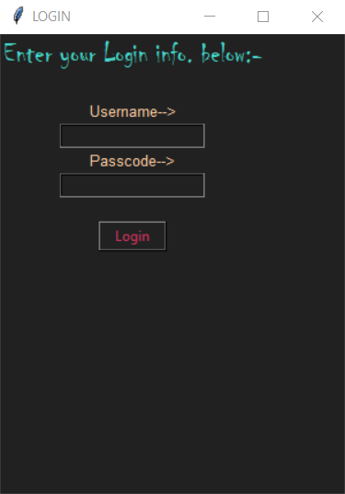

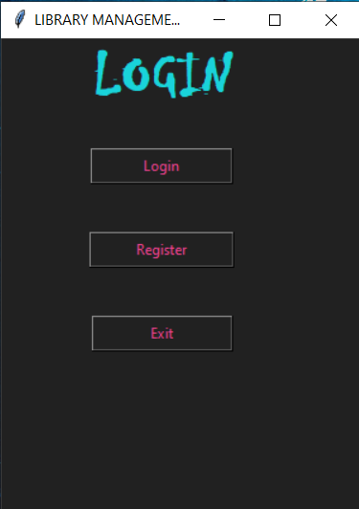

**Main Menu**

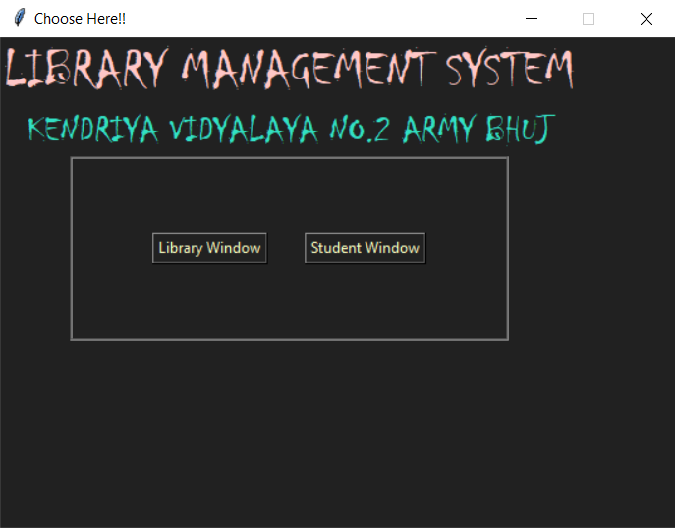

**Library**

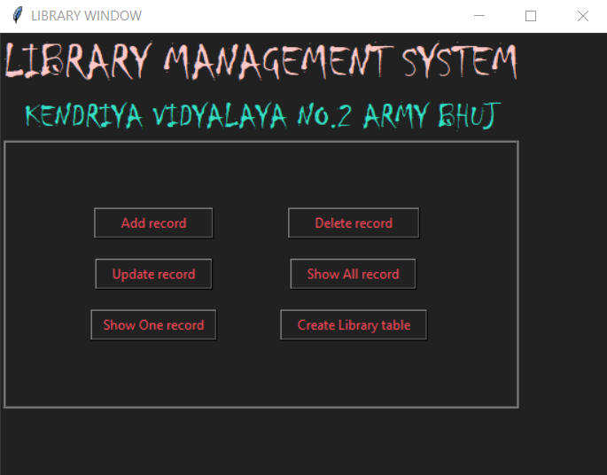

**Student**

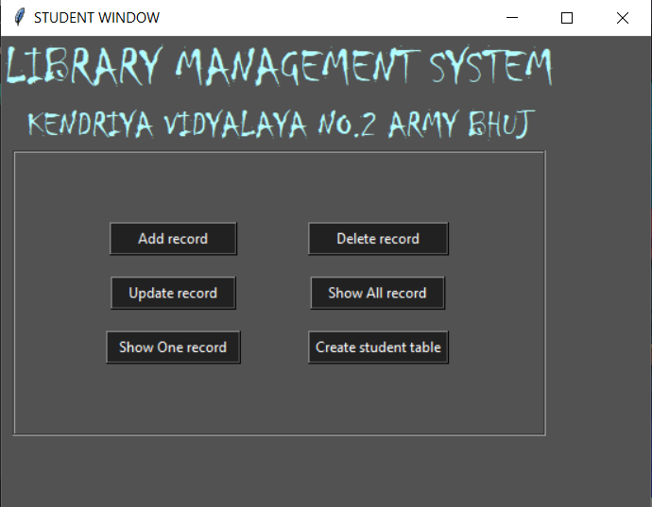

**Add Window**

**Library**

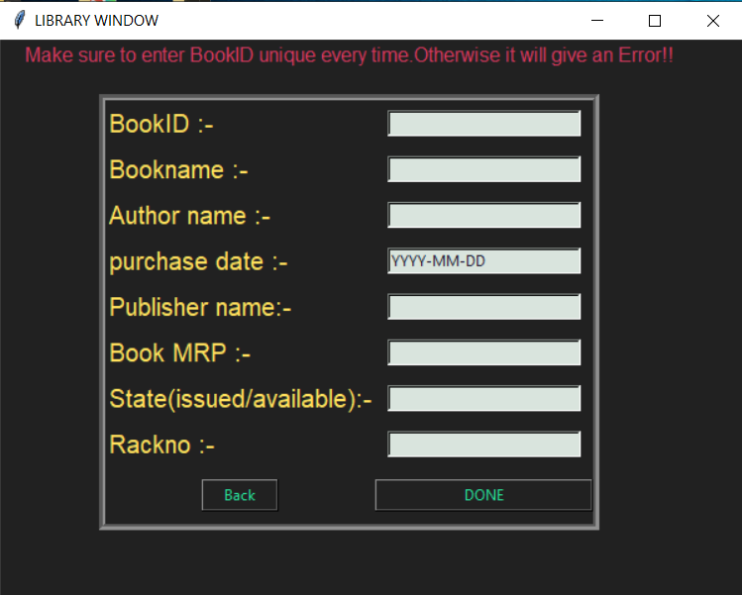

**Student**

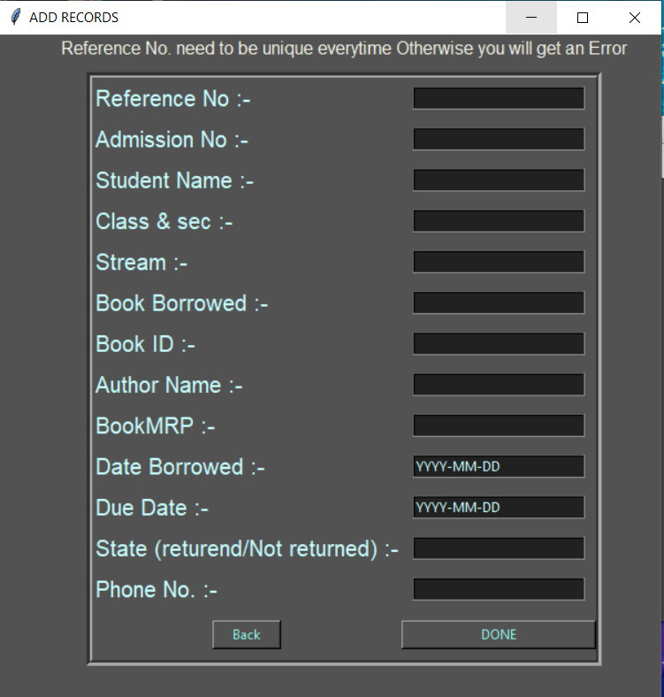

**Update Window**

**Library**

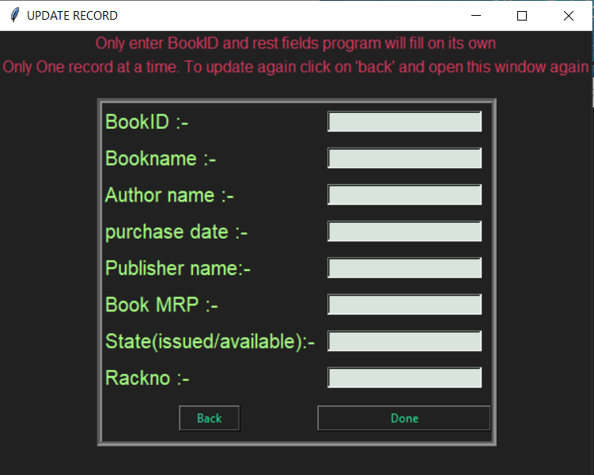

**Student**

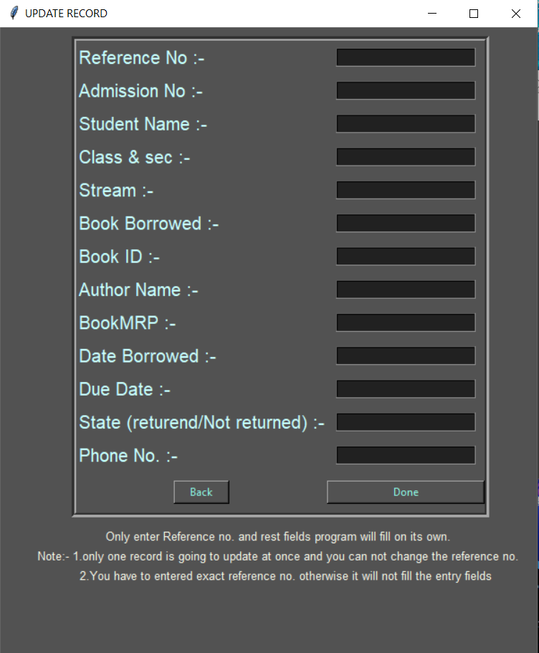

**Show Details**

**Library**

**[One detail at a Time]**

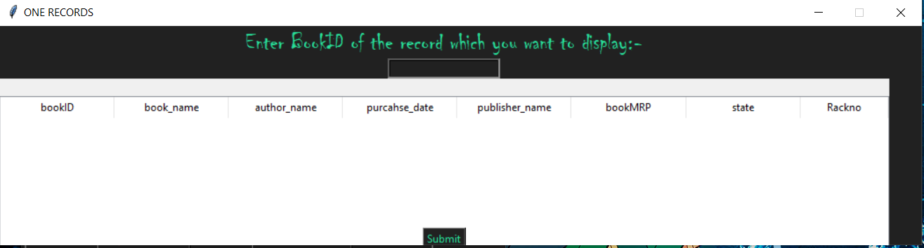

**Library**

**[All details at Once]**

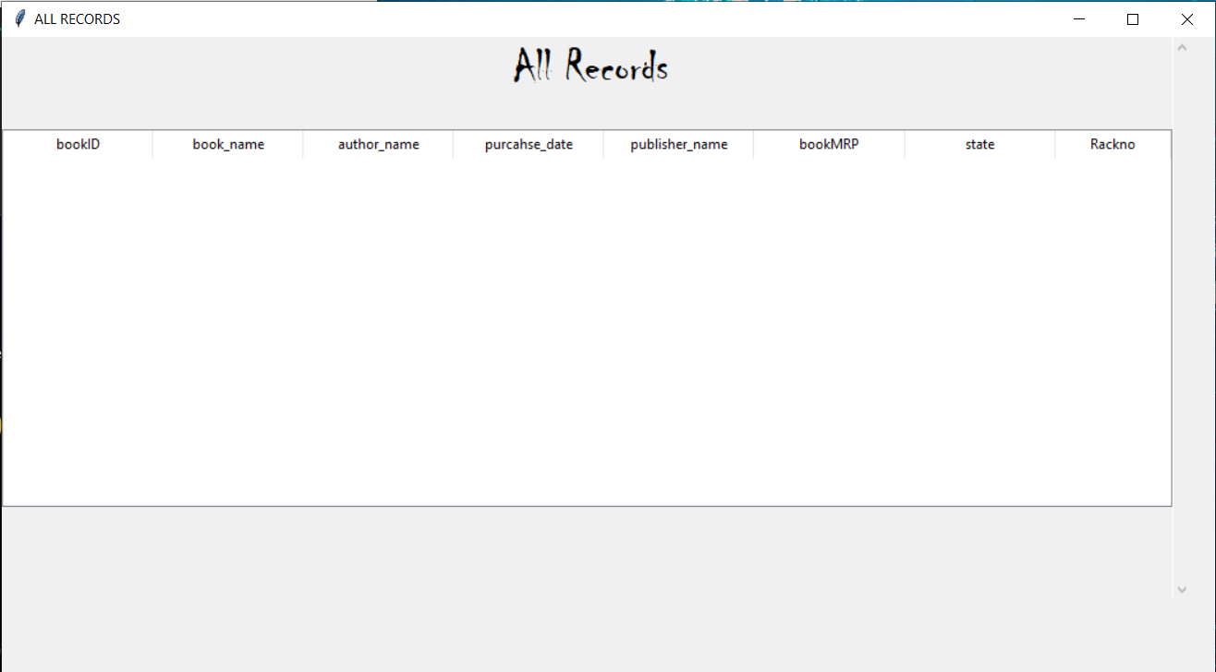

**Student**

**[One detail at a Time]**

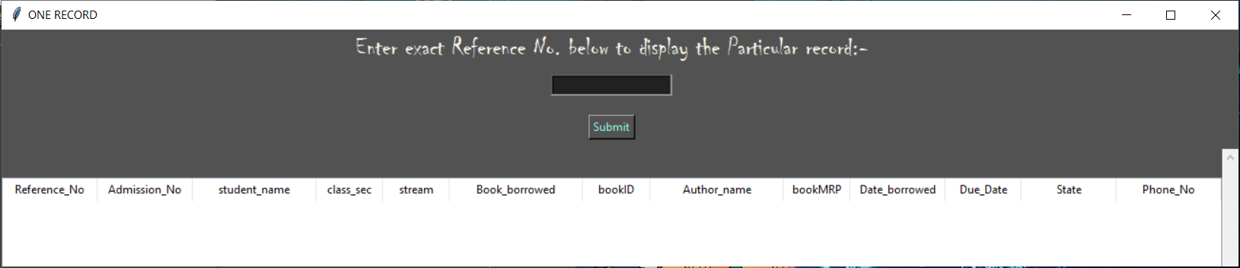

**Student**

**[All detail at Once]**

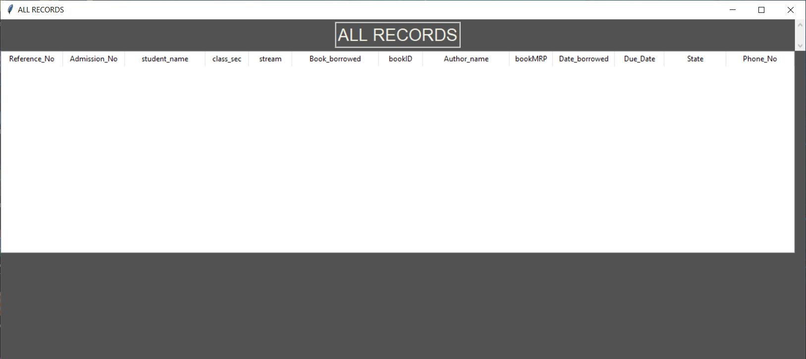

**Delete Details**

**Library**

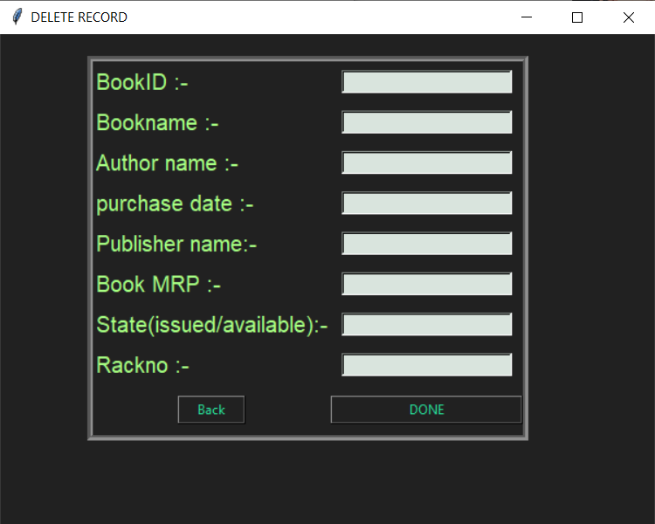

**Student**

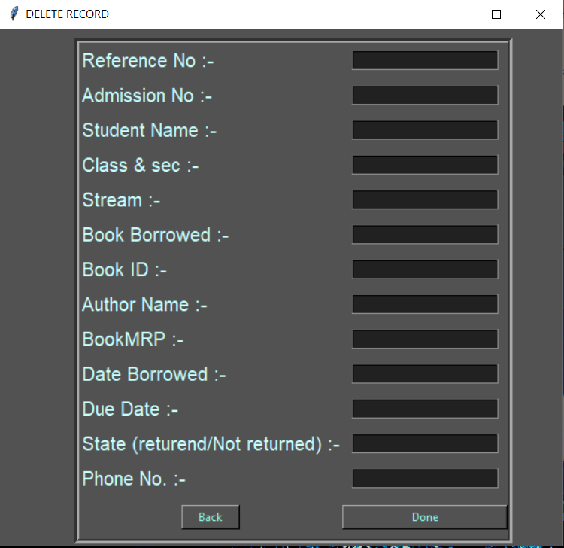

**Create Database or Table**

**[Same for Library and Student Window]**

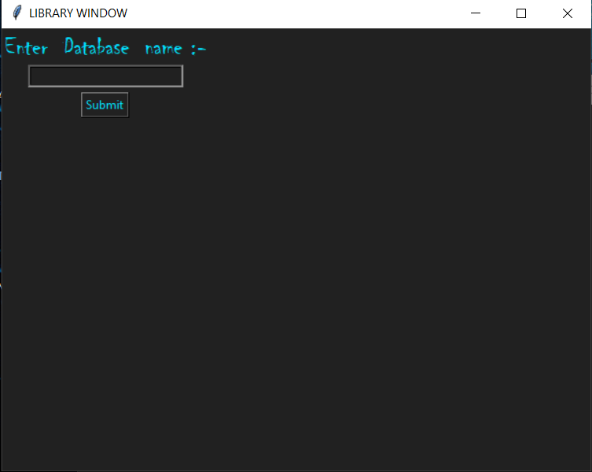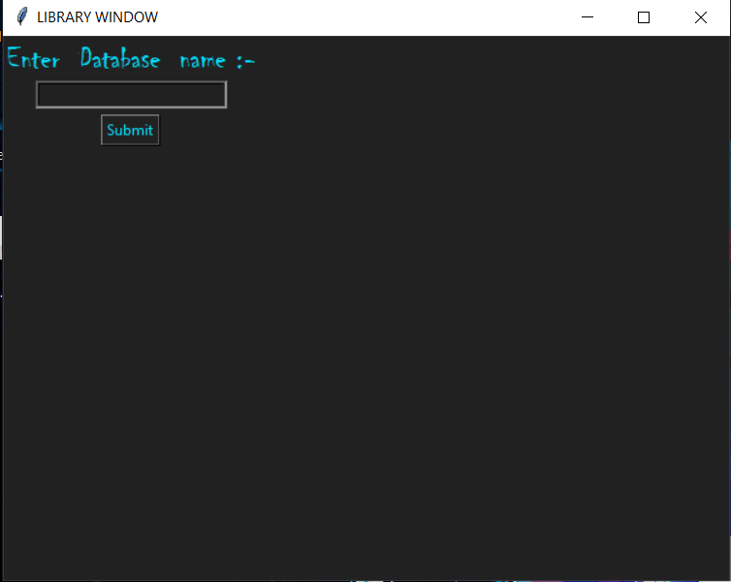

**BIBLIOGRAPHY**

* [**https://www.google.com**](https://www.google.com)
* **https://pythontrends.wordpress.com/**
* **Computer Science with Python by Sumita Arora**